How Do Categories Work?
Categories dynamically create the two main navigation areas ‘Public Officials’ and ‘Topics’ which allow users to browse the School of Government content by subject matter or target audience showing the most recent updates.

In addition, categories can be used to filter searches in the main website search, in the course catalog or in the publication catalog. This makes it easier to locate resources based on a specific topic or relevant to a particular audience and thus makes searching for information more convenient for website visitors.

Category Driven Menus:
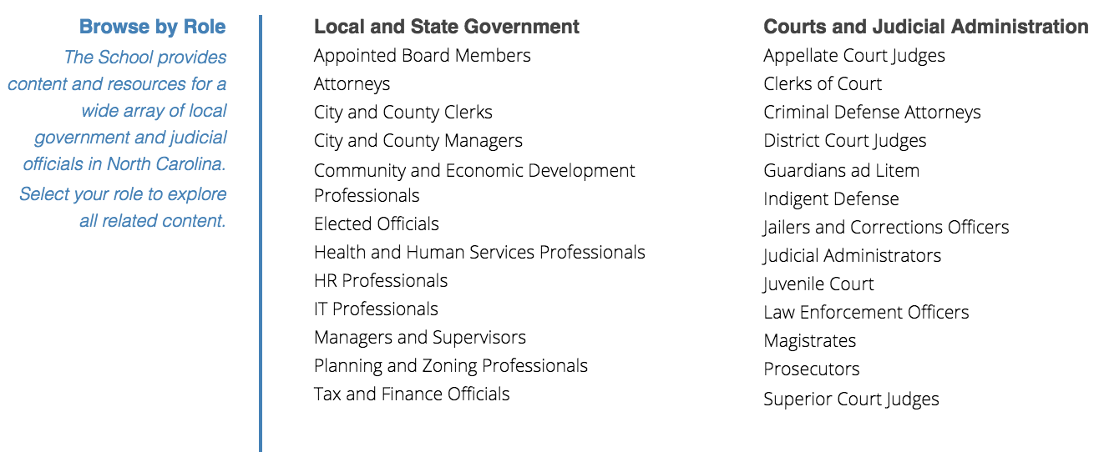

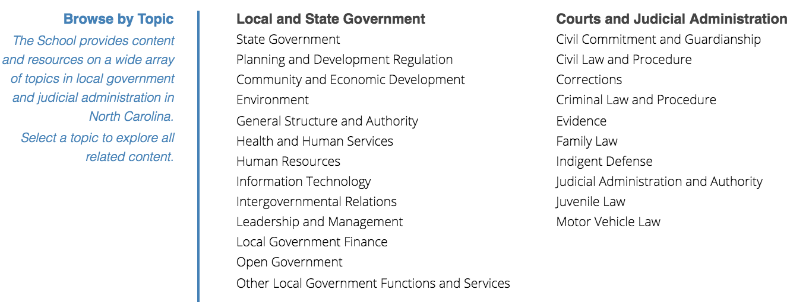

Main Site Search: Categories
In this sample search, all result that shows up will have “water” in the title and “Community and Economic Community Development” as a category.
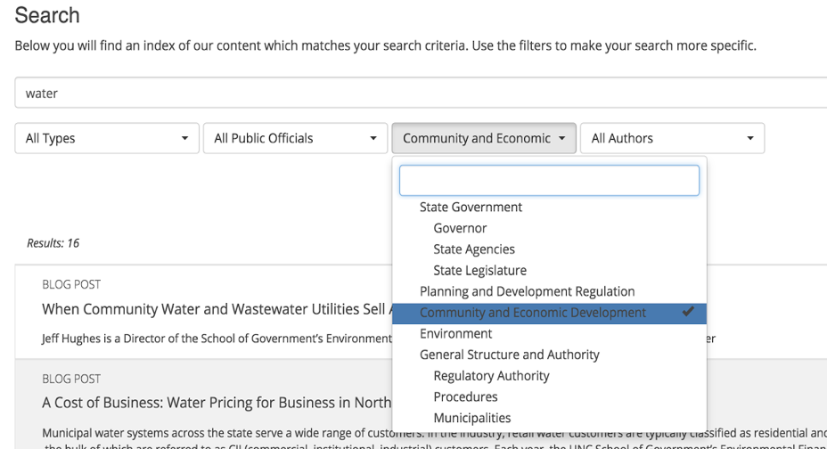

Categories in the Course and Publications Catalog:

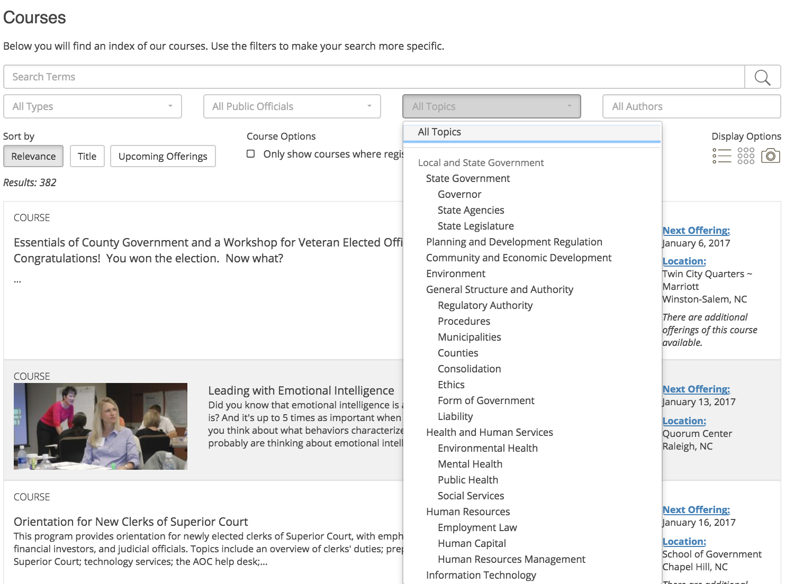
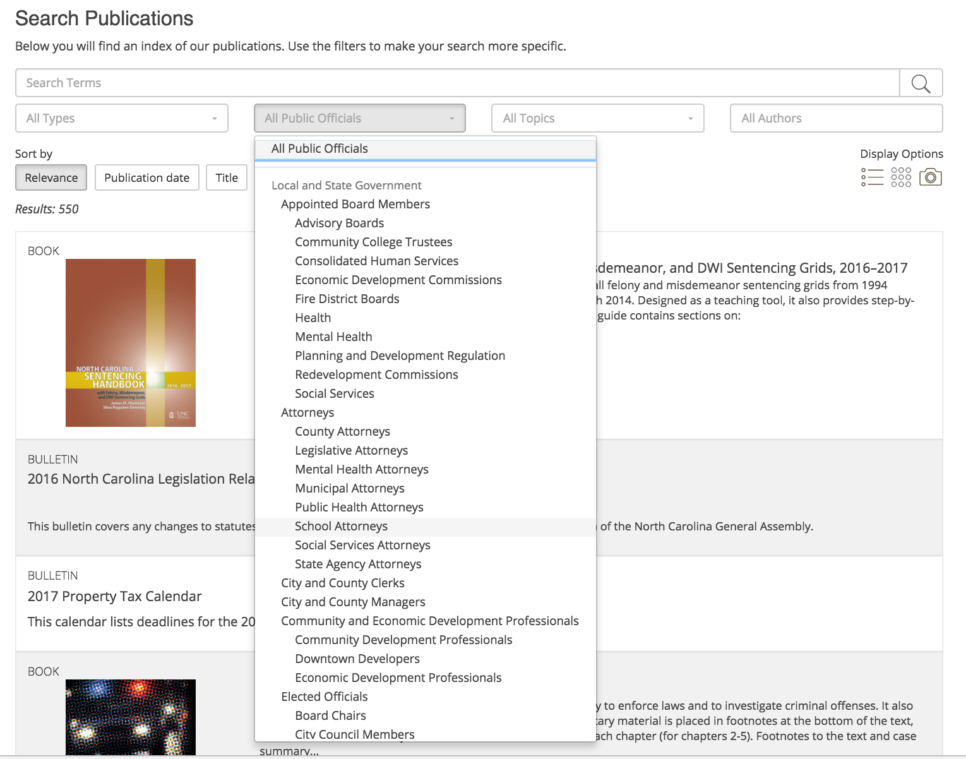

As an example, this selection only provides publications relevant to city council members, narrowing the 550 resources in the catalog down to 20.
