How can I access and edit the Intranet?
The Intranet is located within the School of Government website. However, its content is not accessible to the public and is not indexed in the site-wide search. To access the Intranet, use the menu link ‘Employee Intranet’:

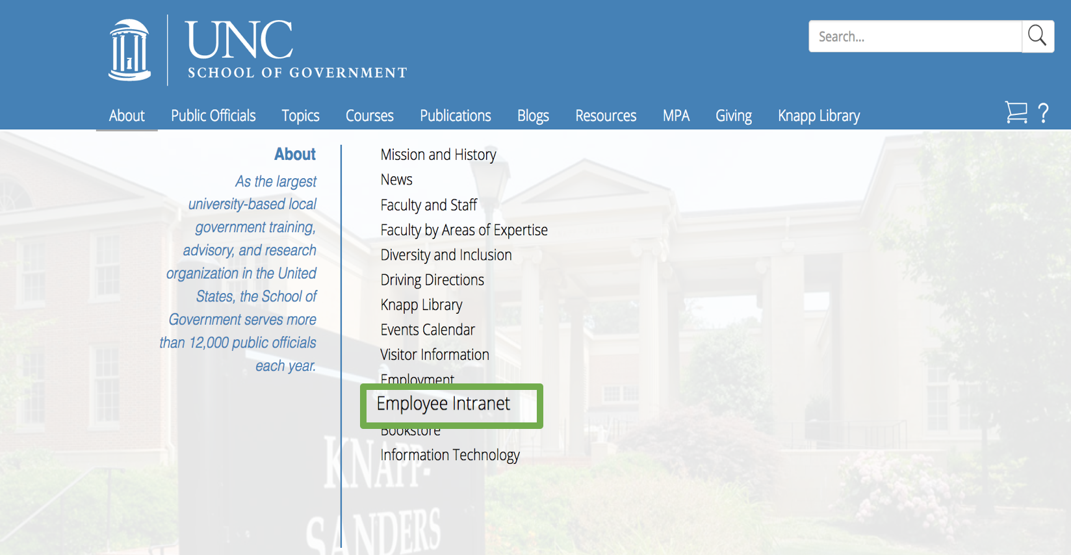

You will be prompted to log in. All employees and former faculty have access.
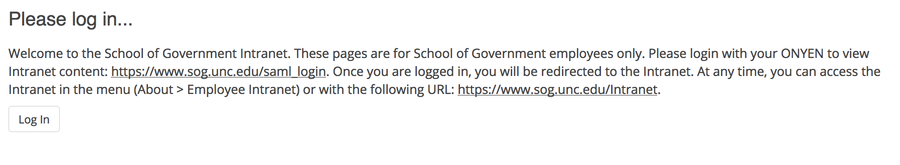
You will be directed to the single sign-on service by UNC.
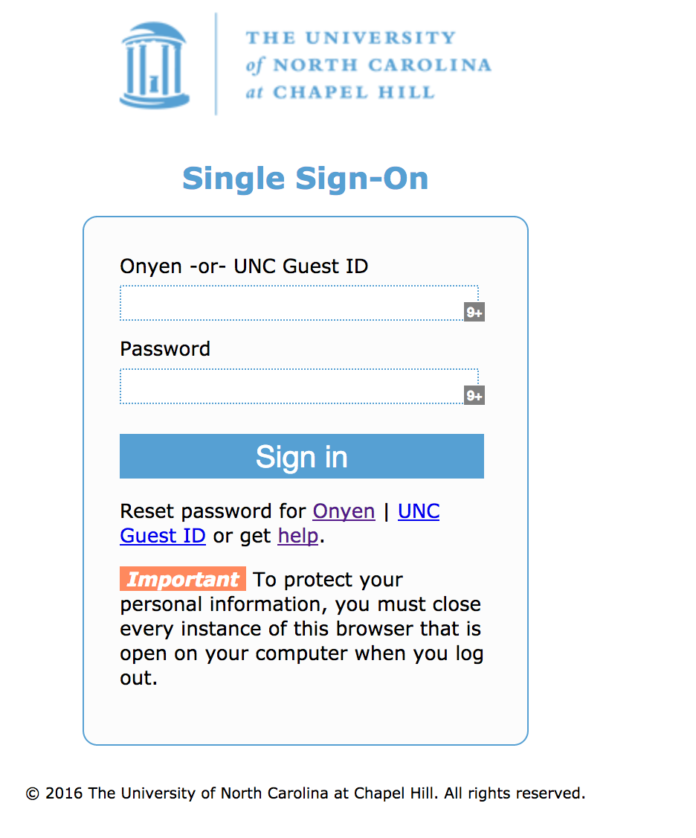
Your screen now shows the Intranet main navigation page – all Intranet resources are linked from this screen.

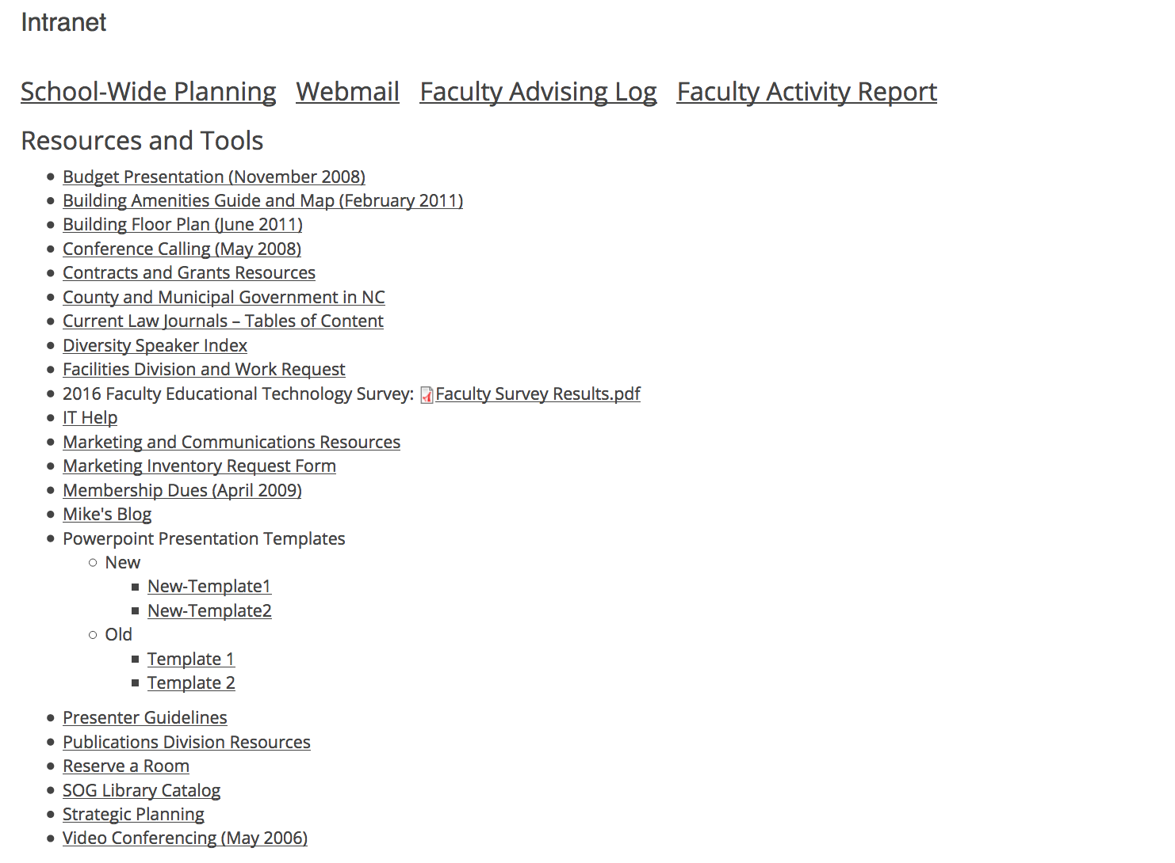

Once you access a specific resource, you can navigate back to the Intranet home screen by using the back button in your browser.

Example:
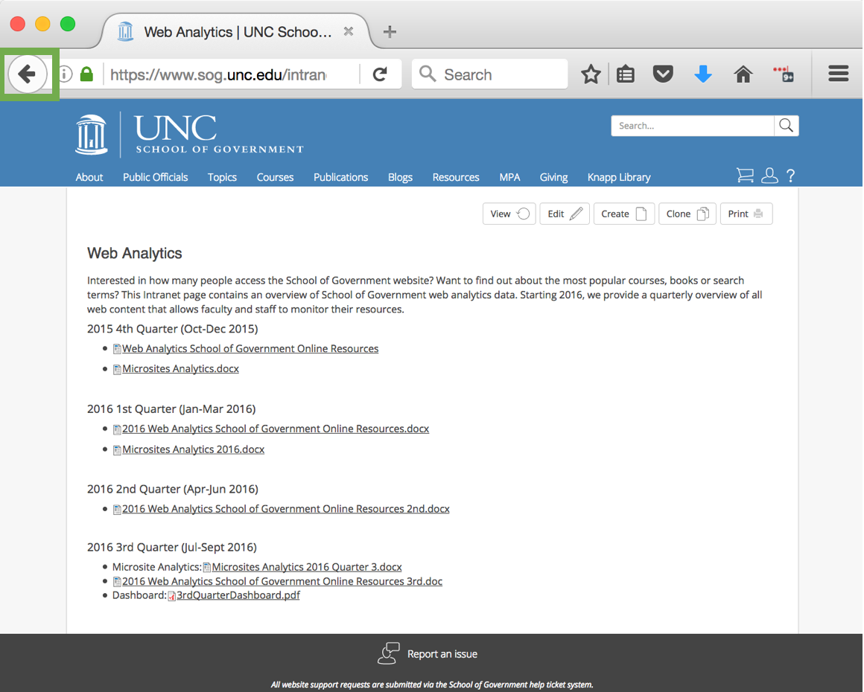
https://www.sog.unc.edu/intranet-source/web-analytics

If you need to add content to the Intranet, your first step is to navigate to the ‘Editor Tools’.
- Use the content type Intranet page to add a page with web content.
- Files (e.g., PDF documents) can be added directly to the files directory – they will not be indexed in the site search.
