How can I add images?
You can add images to the School of Government website on all pages. The easiest way is to use the designated ‘Cover Image’ field that is included in many content types. This way, your image will be featured on overview pages and make your content stand out in search results. You can also add and edit images with the WYSIWIG editor.

Content with Cover Images / image fields:

Most publications (i.e., books, reports) have a cover image (typically the book cover). Marketing staff who are designing the cover can upload it directly to the publication page. If your publication is missing a cover image, send a request to Marketing or take a screenshot of your cover page and upload it as ‘Cover image’.
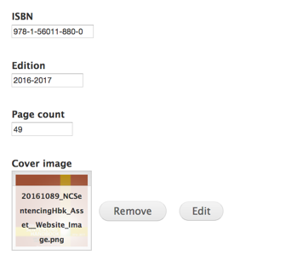
All courses have an optional cover image – contact Marketing (marketing@sog.unc.edu) if you need an image for your course. Note that your course does not need to have a cover image. Below is the display of two sample courses in the online course catalog – with and without image.
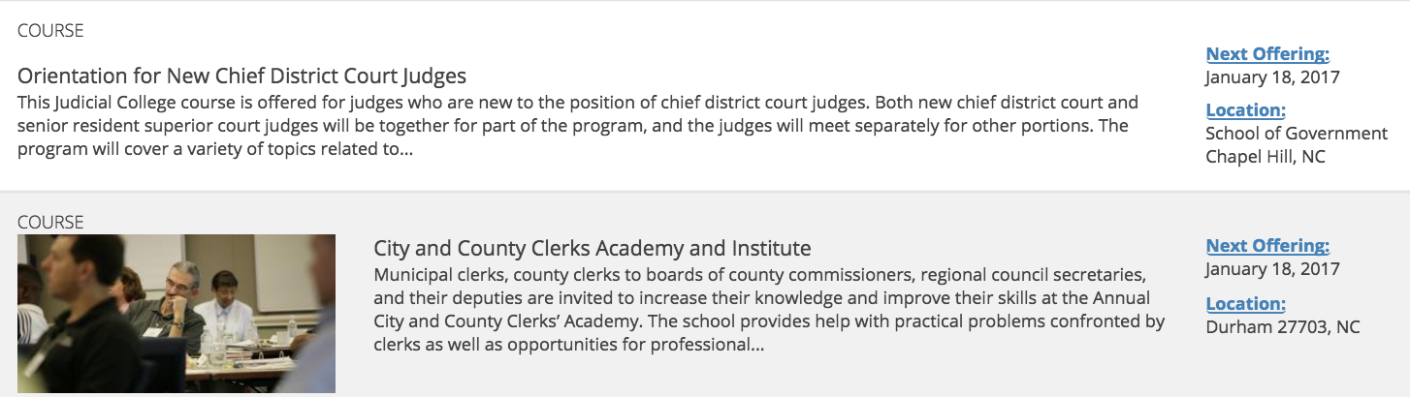

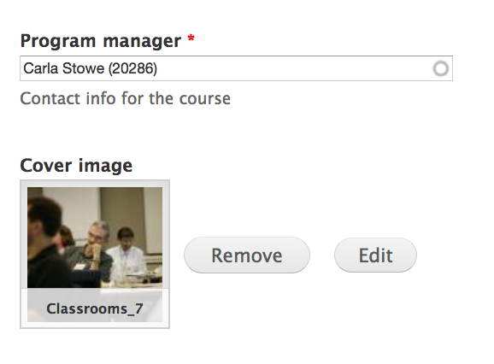

All microsites have an optional banner image.
Below is the display of several sample sites with and without images:

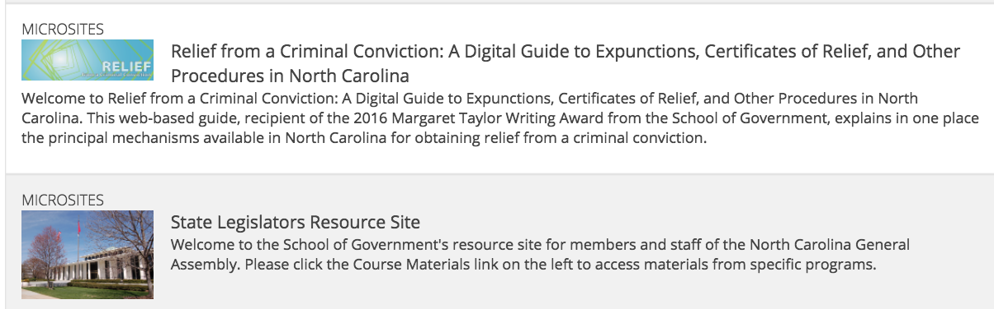
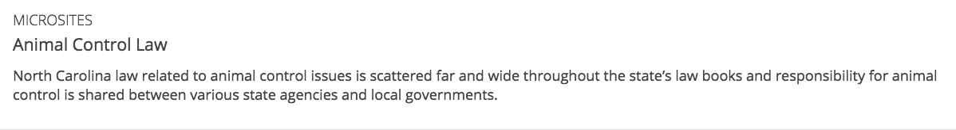

The image can be added as ‘Microsite banner’.
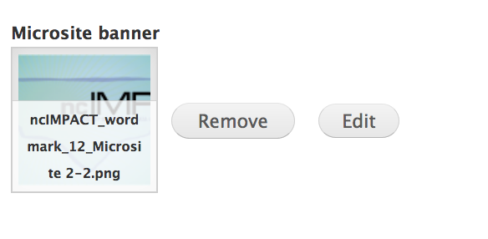
Note that any ‘standard’ web page set up as a basic page can have a ‘cover image’ as well. This is an easy way to add an image to your site without having to worry about alignment, layout or spacing. Again, the image will display on overview pages and in the search results.

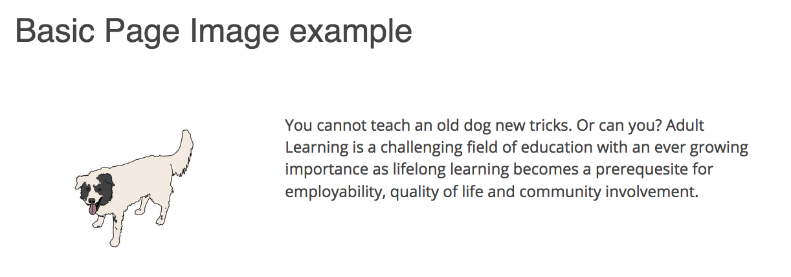
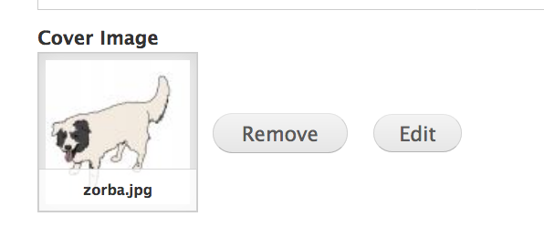
Another option for adding images is to include them anywhere in the main text of your page with the WYSIWIG editor. This is a two-step process. First, you need to upload the image, then you need to align it (and possibly resize).
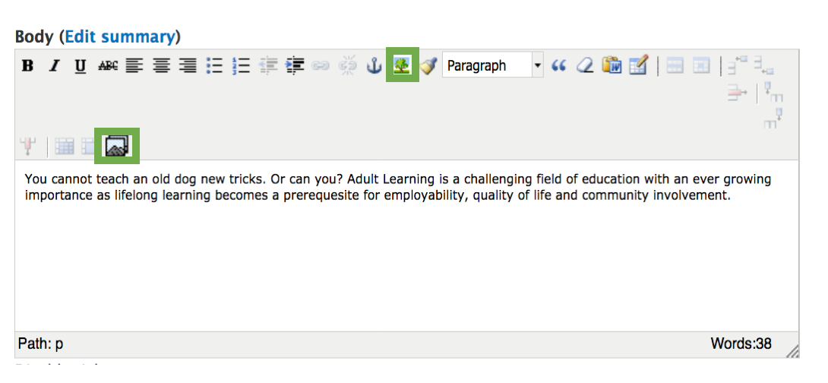

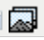 Image upload: This button lets you upload any file to the website’s file directory. You can upload a new file or select an existing file – either from the general library that contains everybody’s data or from your personal uploads (‘My files’).

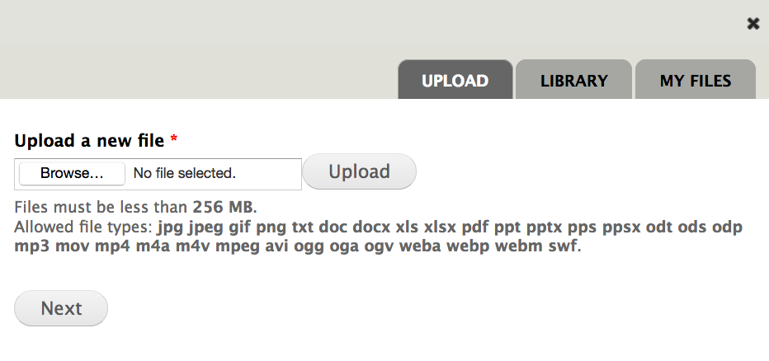
If your are choosing from existing uploads, select an image, scroll down, and click ‘submit’:
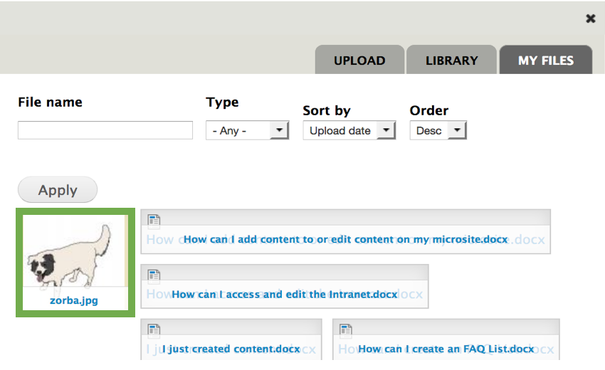
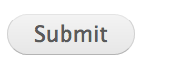
You will be presented with a preview of your image and several optional fields:
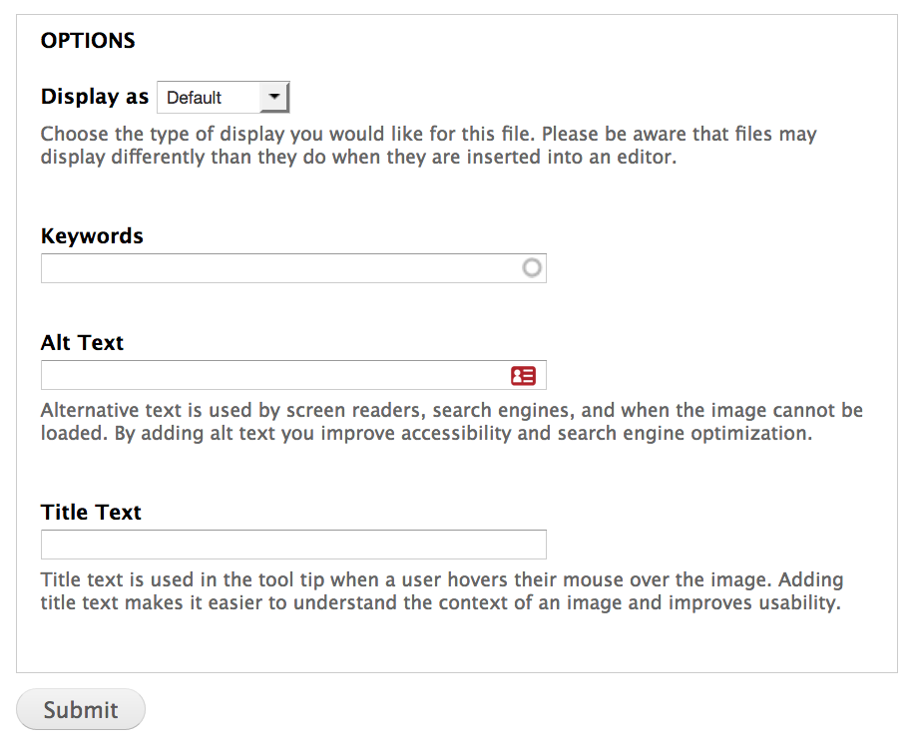

- Leave the display setting as ‘Default’.
- Add keywords if you want to make it easier for yourself and others to retrieve the image for later reuse.
- Enter ‘Alt Text’ to enhance accessibility.
- Entering a Title text will (a) make it easier for yourself and others to retrieve the image for later reuse and (b) provide a tool tip for external users.

Again, confirm by clicking ‘Submit’.

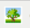Image layout: Your image will now display in the WYSIWIG editor – but it may not look like you want it to. Maybe it is too large, not aligned with the paragraph or too close to the text. You can use click on the image and then the image layout button to edit your image.

- Alignment: Typically left, middle or right.
- Dimensions: depending on if your image is to display next to a paragraph or centered between sections.
- Vertical / Horizontal Space: Creates spacing around your image.

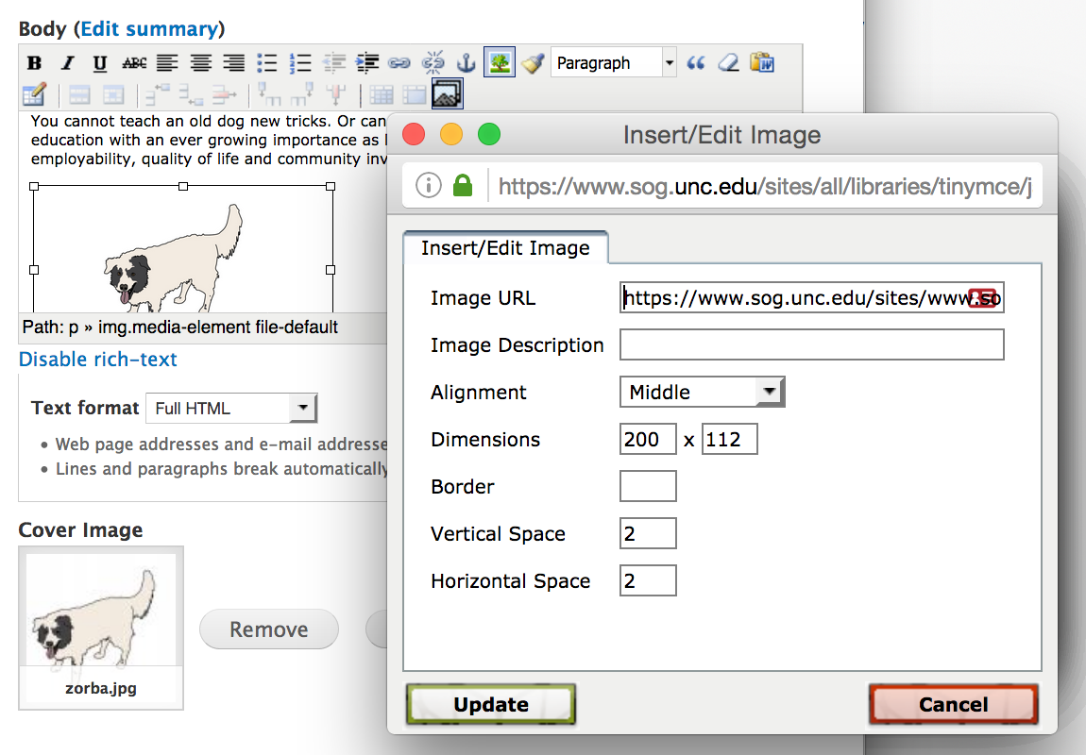

Note that you can also use this button to insert images from the web without saving them to our server by adding the image URL.

