How can I add videos?
You can add video elements to any page you want by using a specific field setting in the WYSIWIG and entering the ‘embed code’ from a social media video sharing site such as youtube or vimeo.

You can find a selection of videos that are approved by Marketing on the School’s youtube channel: https://www.youtube.com/user/UNCSOG/videos

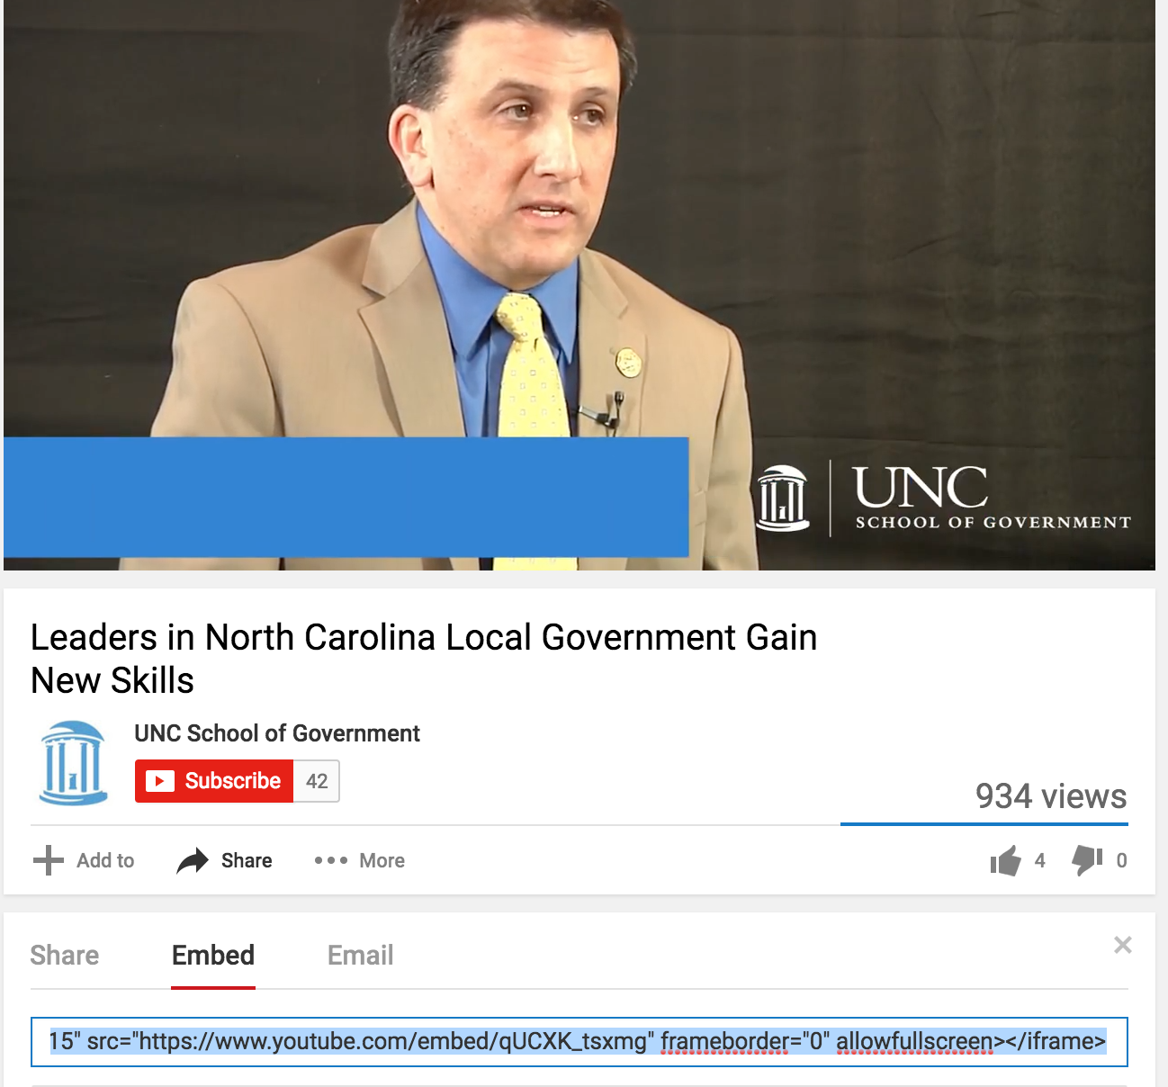

Copy the embed code underneath the video.

To enter the embed code, you need to switch the ‘Text format’ to ‘Embedded video’
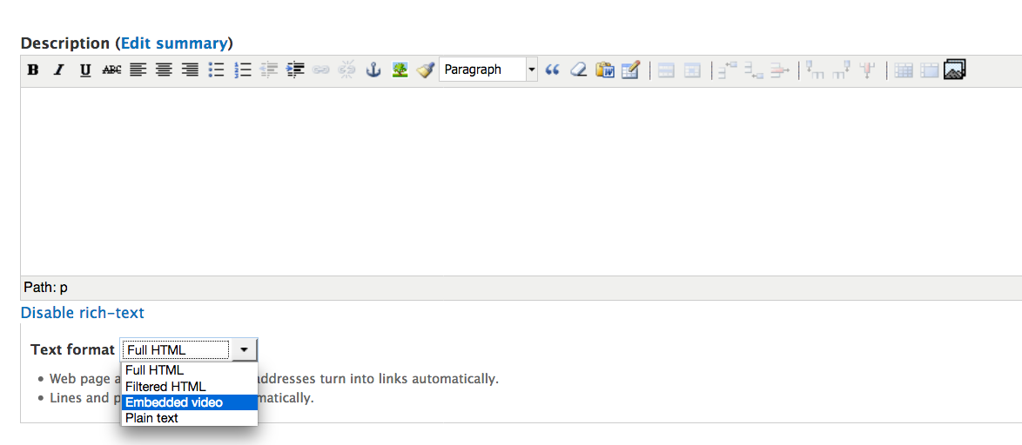
Paste your embed code at the position where you want the video to appear.

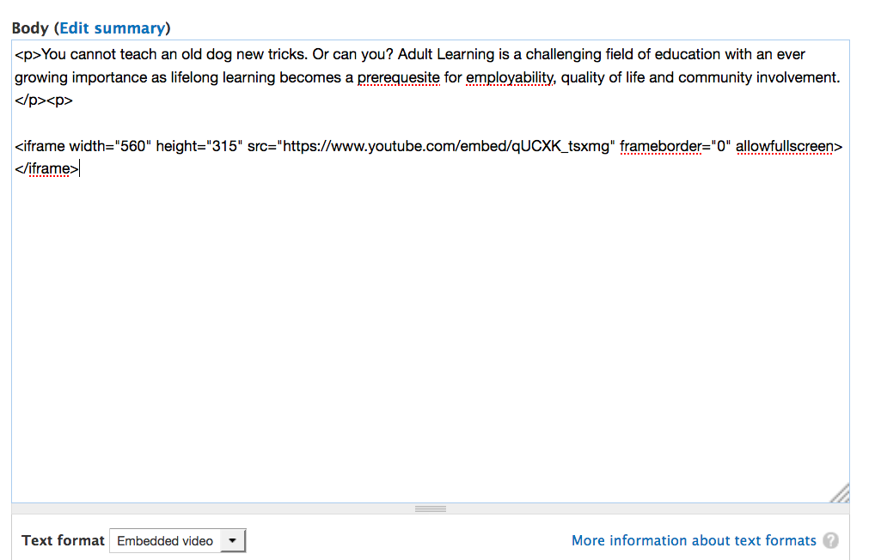

Switch back to ‘Full HTML’ to see the result.

Click ‘Save’. Your page will now include the video.

