How can I add a new link or fix a broken one?

Most hyperlinks are added and edited in the WYSIWIG editor. You can add a hyperlink to any text or image by clicking on the ‘chain’ symbol. In addition, many content types have a field for
external URLs.

To enter a new hyperlink, select the text or image you want the link to be placed on. Choose the anchor symbol in the editor menu.
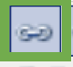

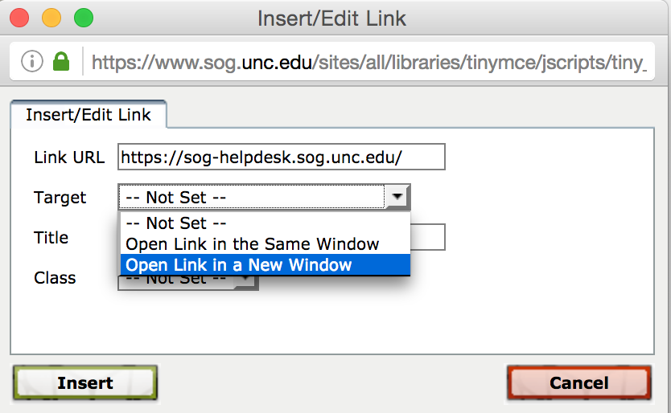

- Enter the link URL.
- Select ‘Open Link in a New Window’ if you want the link to open in a new browser tab.
- Click ‘Insert’.

Fixing Broken Hyperlinks:
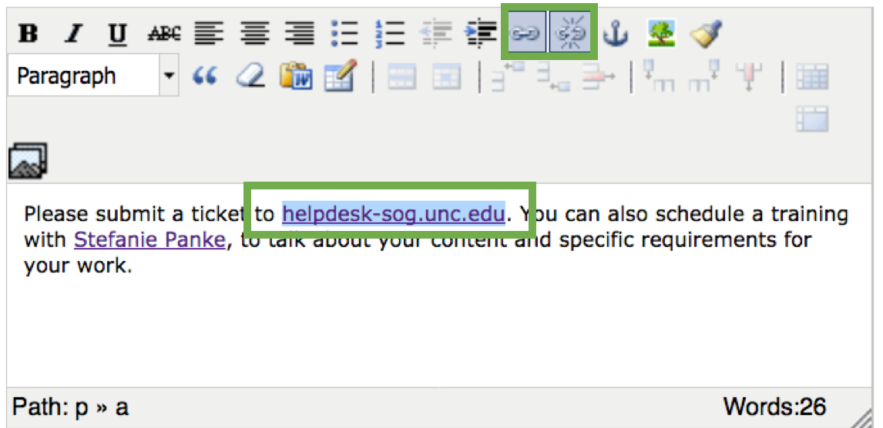

Fixing a broken link is a three-step process. First, select the hyperlink.
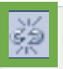Second, unlink the hyperlink.
Third, select the text you want to hyperlink, and create a new hyperlink. Click ‘Update’ to confirm.

