How can I upload or edit publications?
All School of Government publication (books, bulletins, reports, articles) are listed on each faculty member’s profile and are searchable in the publication catalog as well as in the main website search. Typically, the publication division will add books and bulletins. Faculty may need to articles or reports themselves if the publication division was not aware or had no part in the publication process. You may want to check your publication list from time to time to make sure it is up to date, and all publications have the correct categories.

The first step is to see if your publication is already on the website by checking your profile or the publication catalog.

Catalog: In addition to entering search terms, people can search by categories (Public Officials / Topics) and Authors.

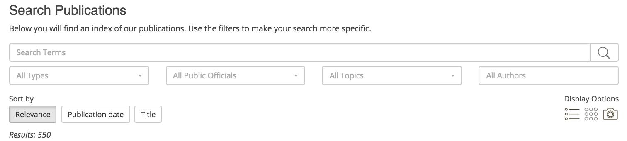

Faculty Profile: Your profile page will list all of your publications, courses and resources. You can edit each publication directly from your faculty profile page.
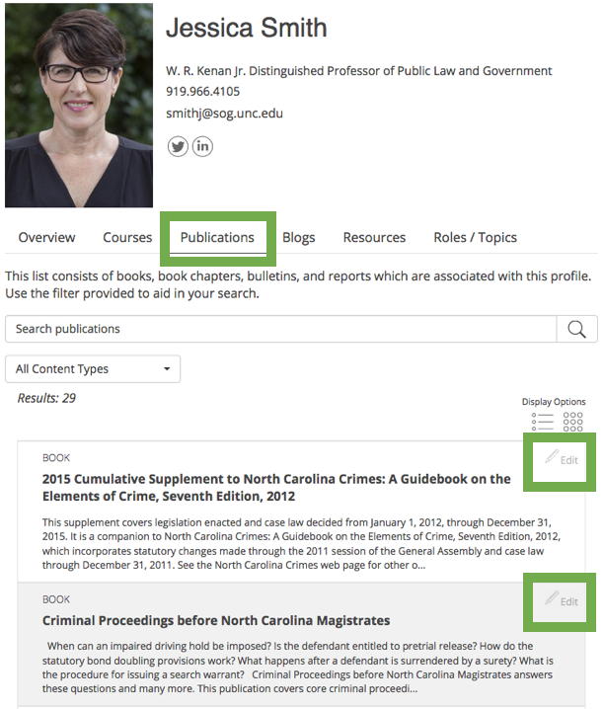

To add a new publication, for instance a report, start with the content editor.
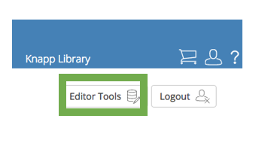
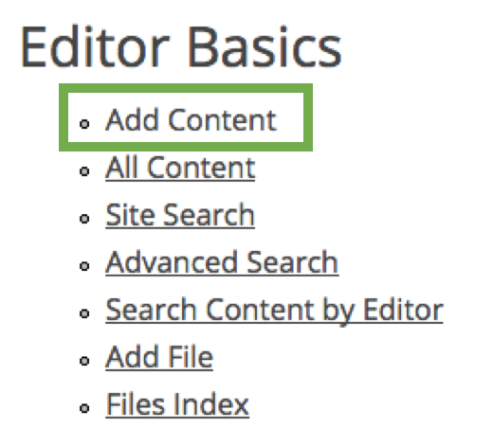

Select the content type you need: book, report, bulletin or article. For edited volumes, first create the book and the create records for each chapter. When people search for the chapter title, they will be redirected to the complete book.

