How to Login
You need to log in to the School of Government website to edit content or to access the Intranet. You do not need to remember a separate password: The website works with single sign-on and uses your ONYEN for logging in. You can find the log in link in the footer or directly at https://www.sog.unc.edu/saml_login.

- Go to http://www.sog.unc.edu
- Scroll down to the bottom of the homepage.
- Click the “Employee Login” button.
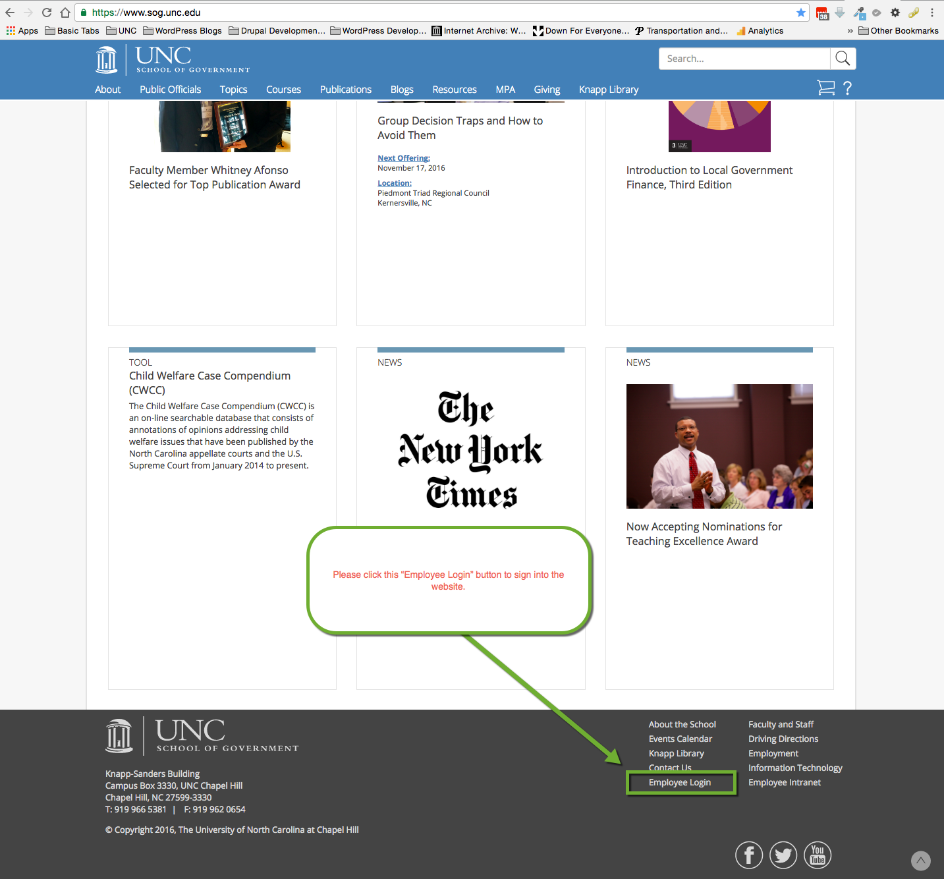
- Now login using the your ONYEN and ONYEN Password.
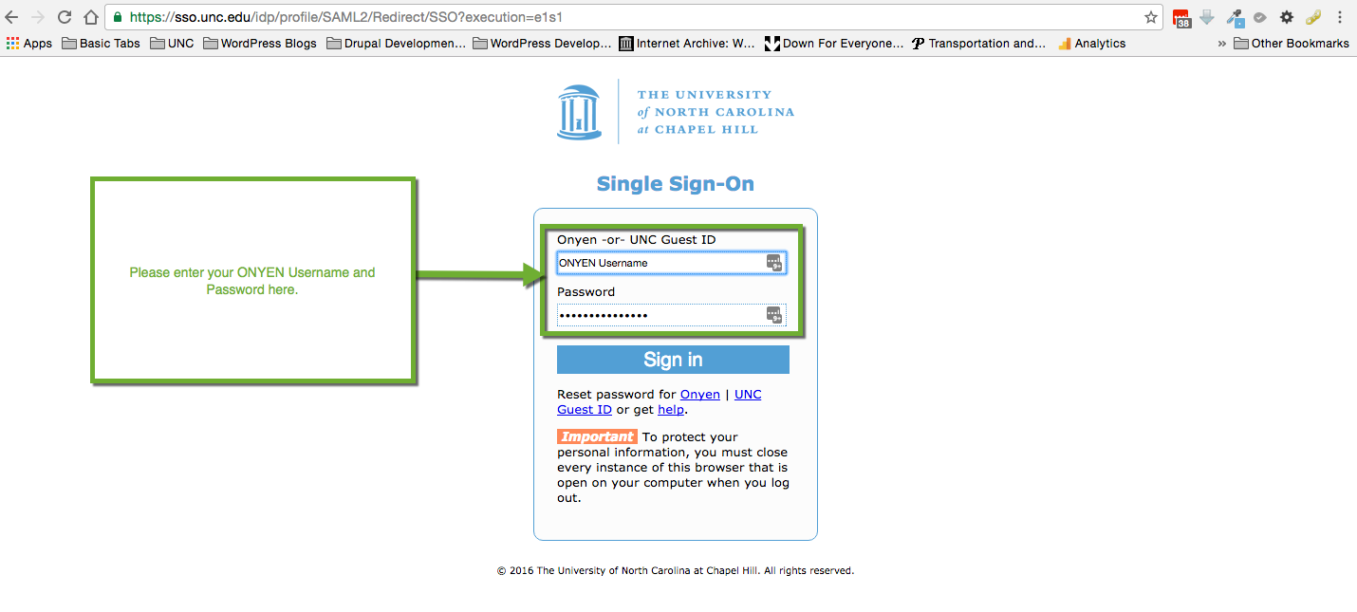
- Click the “Sign In” button now.

Please follow the steps below on how to logout:
- Assuming that you have logged in to the website. At the top of every page on the website you should see a “person/ profile” icon. Click the Icon.
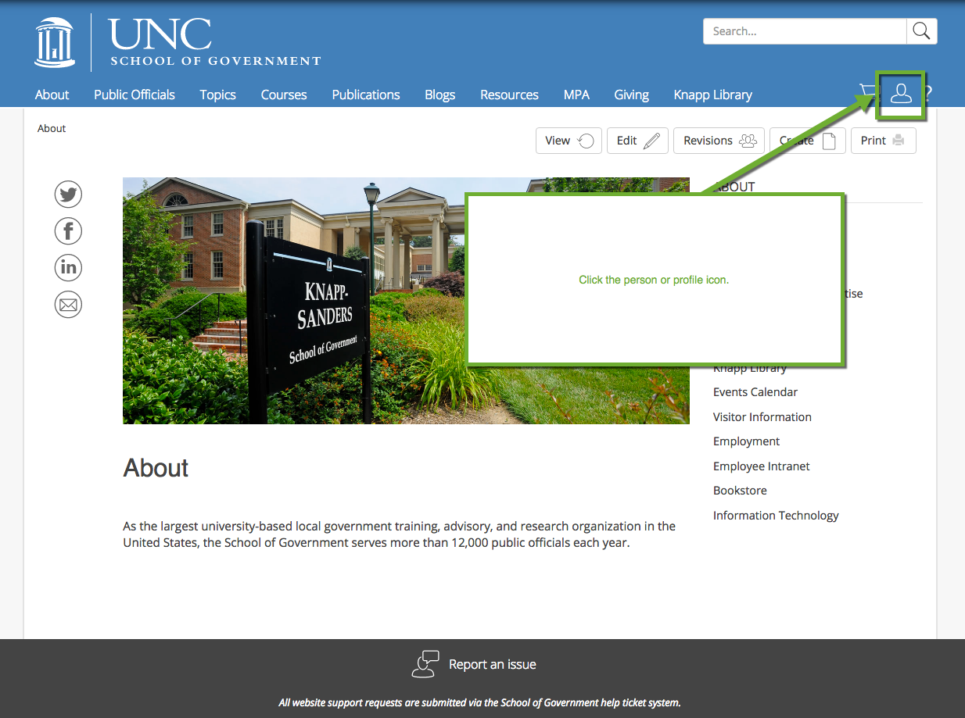
- Under the “person/ profile” icon you should now see a Logout button, click that to logout of the site.
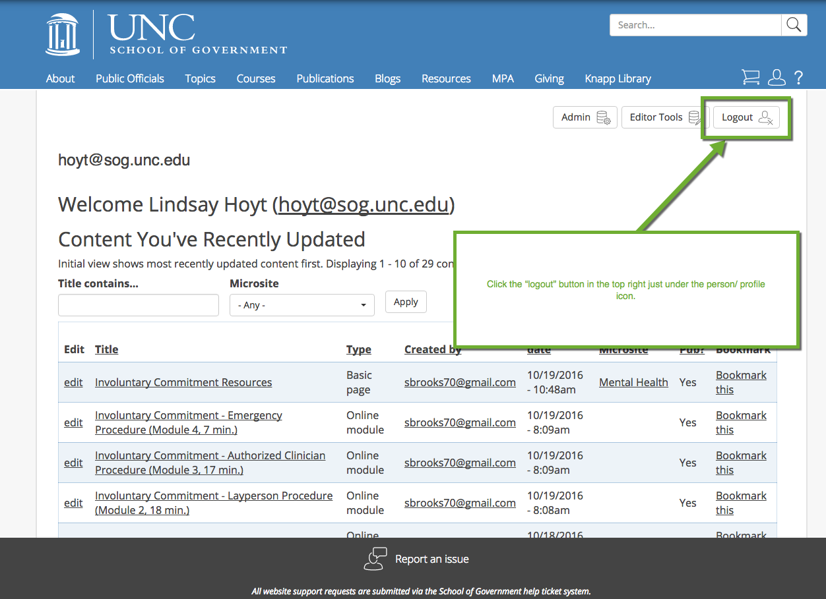

If you see a screen that says you have insufficient access please contact IT at http://sog-helpdesk.sog.unc.edu or click ‘Report an issue’ at the bottom of your screen.

