Oh no! My page looks messed up, the font types and sizes are different. How can I fix this?

Typically, this happens after you copied content from another web page or MS Word. You can get rid off extraneous, inconsistent formatting by selecting your text and clicking on the ‘rubber’ icon. Ideally, choose the option ‘paste from Word’ when adding next content by copy and paste.
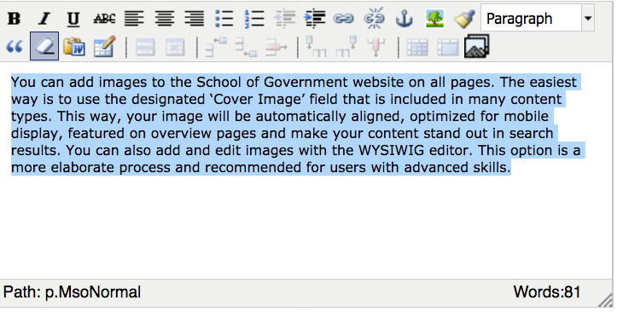

Cleaning up formatting: Select the text and click on the ‘rubber’ icon
Adding new content: Use the ‘Paste from Word’ option

