Pattern Jury Instruction App Cheat Sheet

Log In
https://pji.sog.unc.edu/
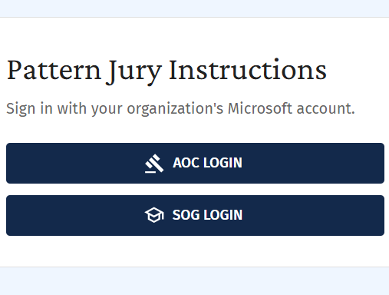
- Choose AOC Login and follow AOC login procedures
- Once logged in, download the desktop application and use this version going forward

Landing Page
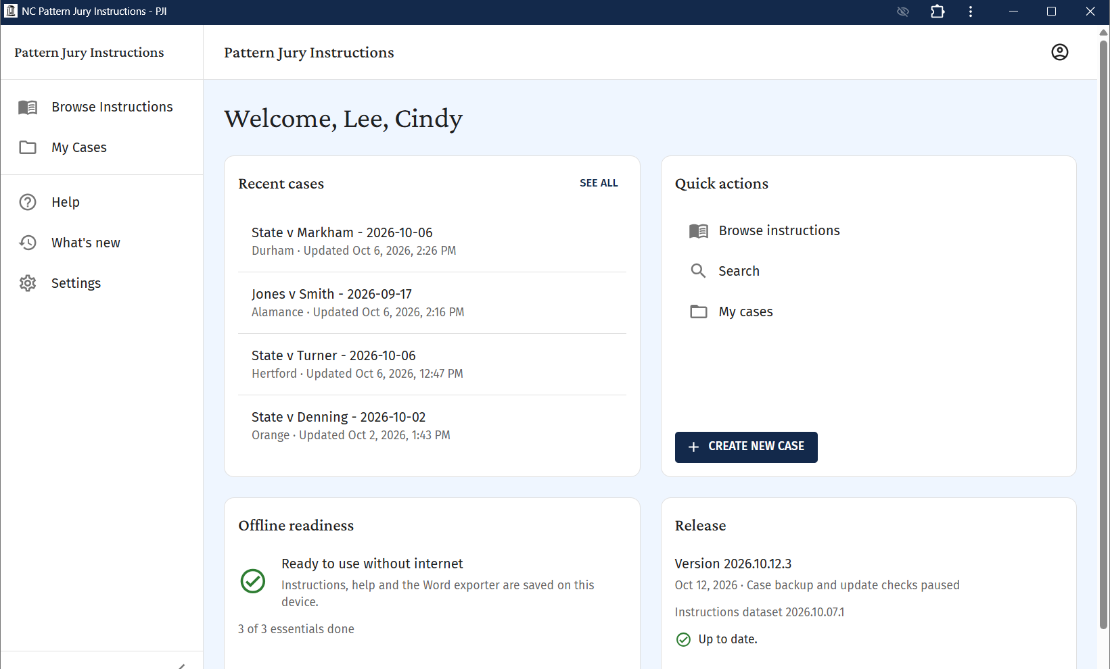
- Menu option descriptions:
  - Browse Instructions – Use to search and read instructions before adding to a case.
  - My Cases – As case instructions are created, they will be saved here and can be accessed later.
  - Help – More tips and tutorials on how to use this app.
  - Create New Case – Use to start building a new set of instructions for a case.
  - Search – another option for searching for instructions
  - My Cases – list of cases you have created

Browse Instructions
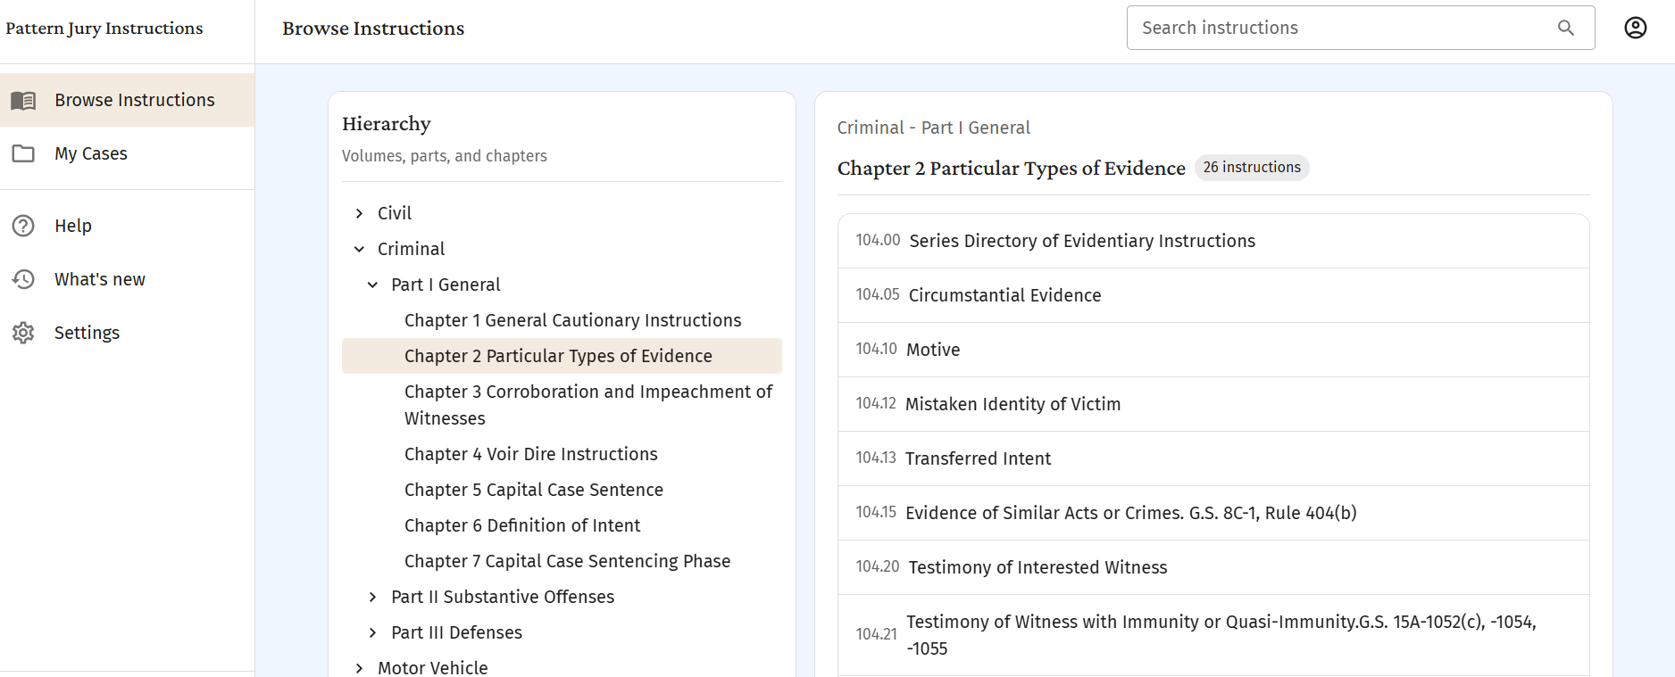

- Under Hierarchy, you will see the breakdown by Volume, Parts and Chapters within those volumes.
  - As you click on a Volume and a Chapter, the instructions within that chapter will be listed in the right column.
- As you click on an instruction in the right column, it will open the instruction up in a new window.
- You will see Note Wells and Footnotes in the instructions (see below).
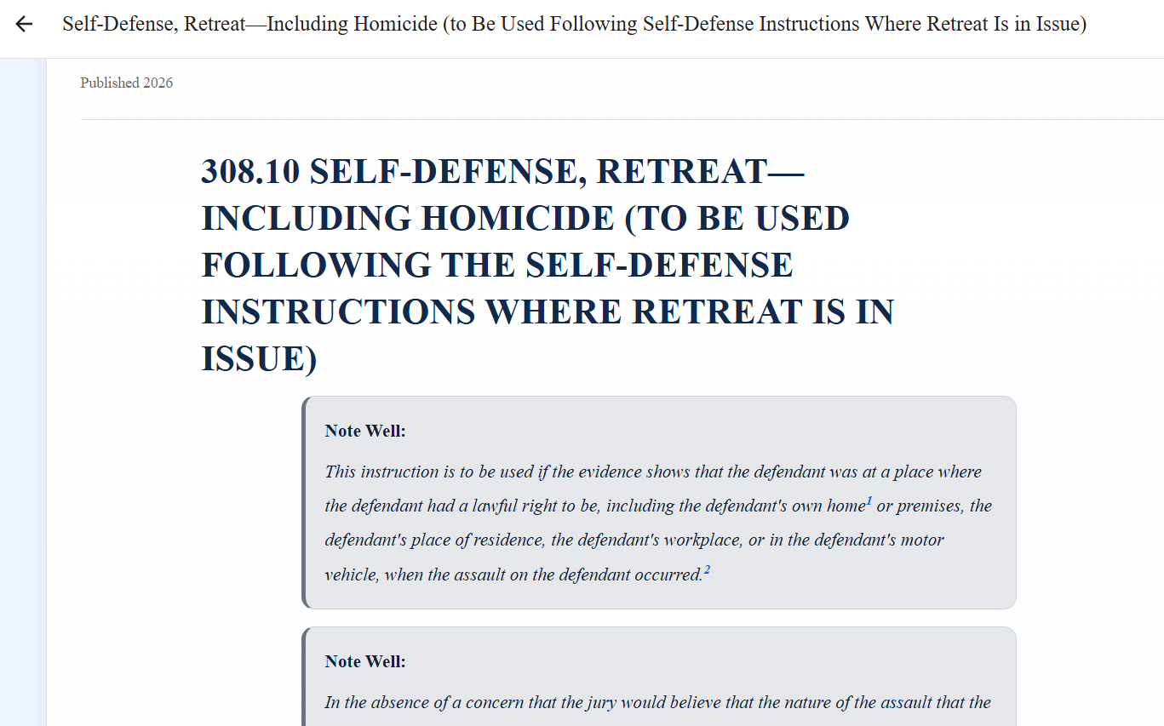

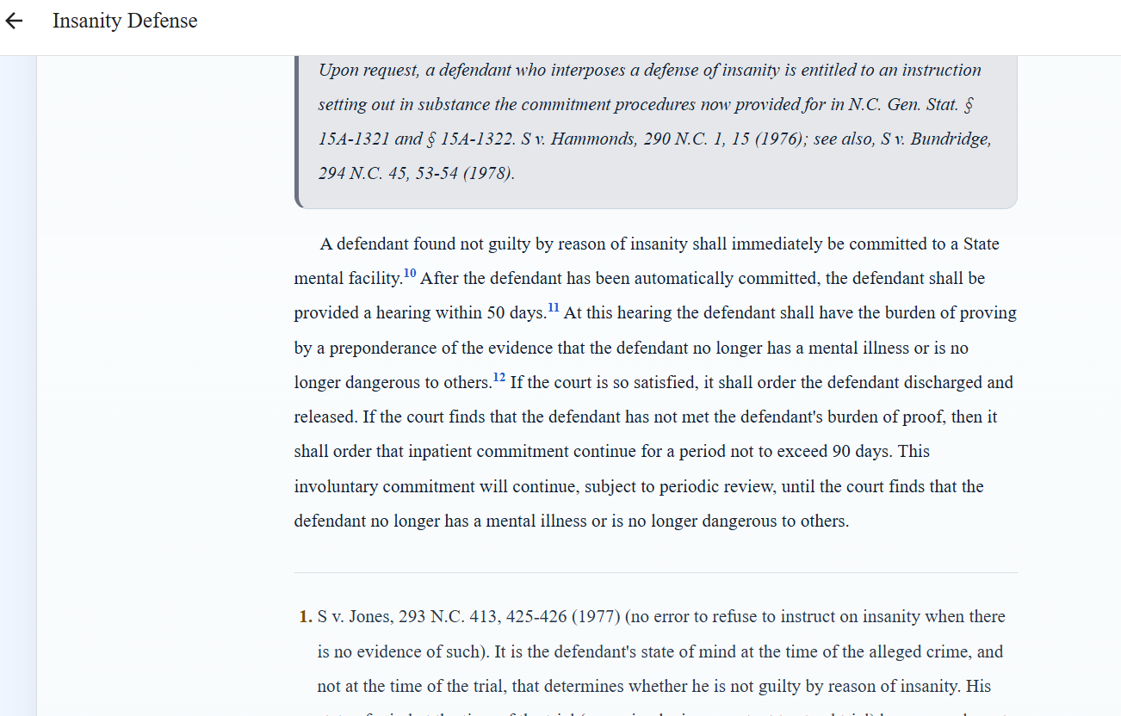

My Cases
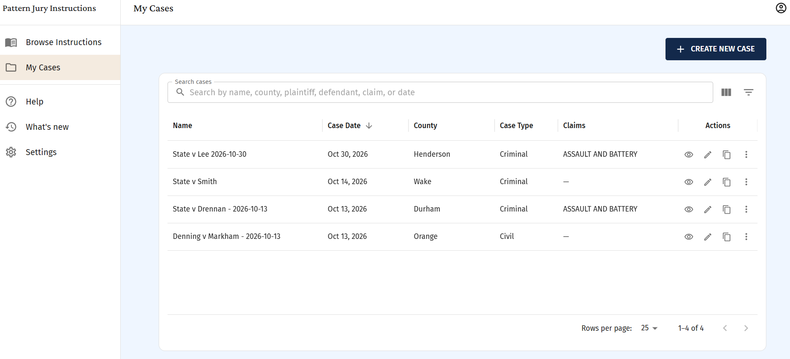
- All previously created cases are saved here.
- Which columns are shown in you My Cases view can be managed by clicking the button in the top right corner.
- You can search My Cases by using the Filter button in the top right corner.
- You can rename, duplicate or delete cases by using the icons to the right of each title.

Create New Case
- To create a new case, click the Create New Case button on the My Cases page or the landing page when you log in.
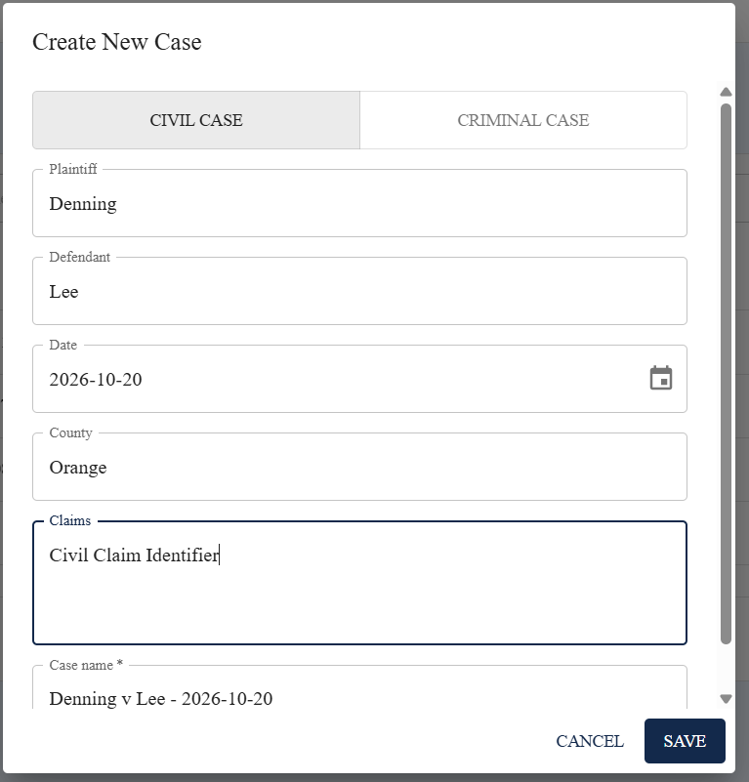
- You will choose whether you are starting a set of instructions for a Civil Case or a Criminal Case.
- You will fill in the fields in the pop-up box, including names of parties, date of case, county of case and any claims for the case that you want to list to make this set of instructions helpful to find in the future.
  - Once you add the names of the parties and the date, the Case Name that will be saved auto populates in the final field.
  - If you are creating a Criminal Case, you will type in charges instead of claims. As you start to type the charges, you will get a drop down of charges to choose from.
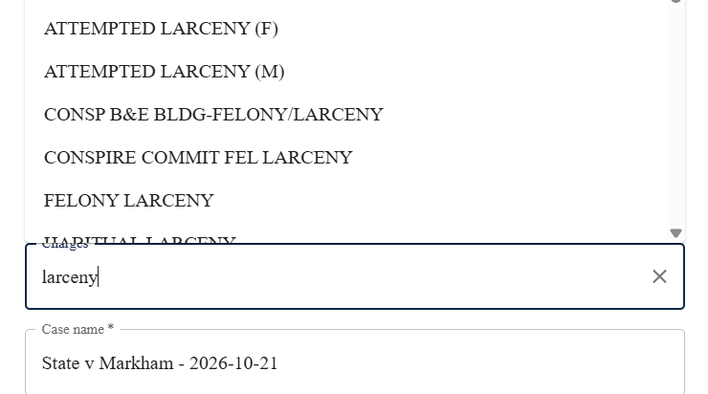
- As you hit Save, your case will be created and the default set of instructions will be added to your case based on the type of case you chose to create. 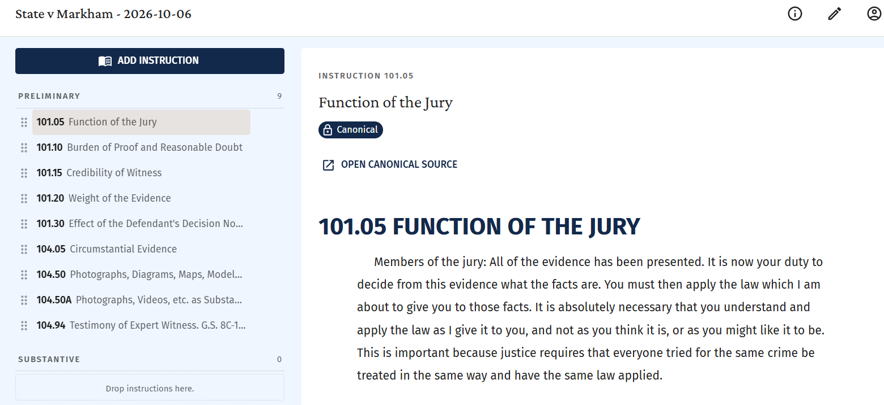
- The instructions are added in the lefthand column. The default instructions are under Preliminary. As you add other instructions, they will be added under Substantive.

- Add Instructions:
  - Click the Add Instructions button and use Search function at the top
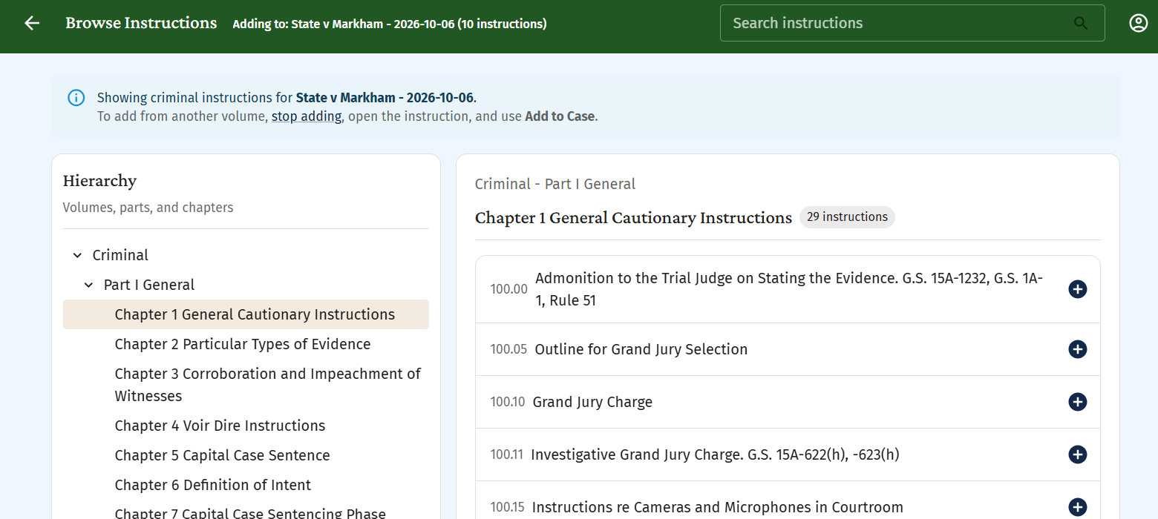
- There are two ways to add an instruction to your case.
  - You can click on the + button to the right of the title of the instruction you want to add.
  - Or you can click on the title of the instruction, which will open a new window showing the instruction and you can click the “Add to Current Case” button in the top right corner.

  - To return to the search and add more instructions, click the back arrow in the green banner at the top.
- If you need to add an instruction from a different volume than appears in the search, stop adding, go out to main menu and browse instructions from the other volume and use Add to Case.
- As you select instructions for the case, they will be added under Substantive in the order in which you add them.
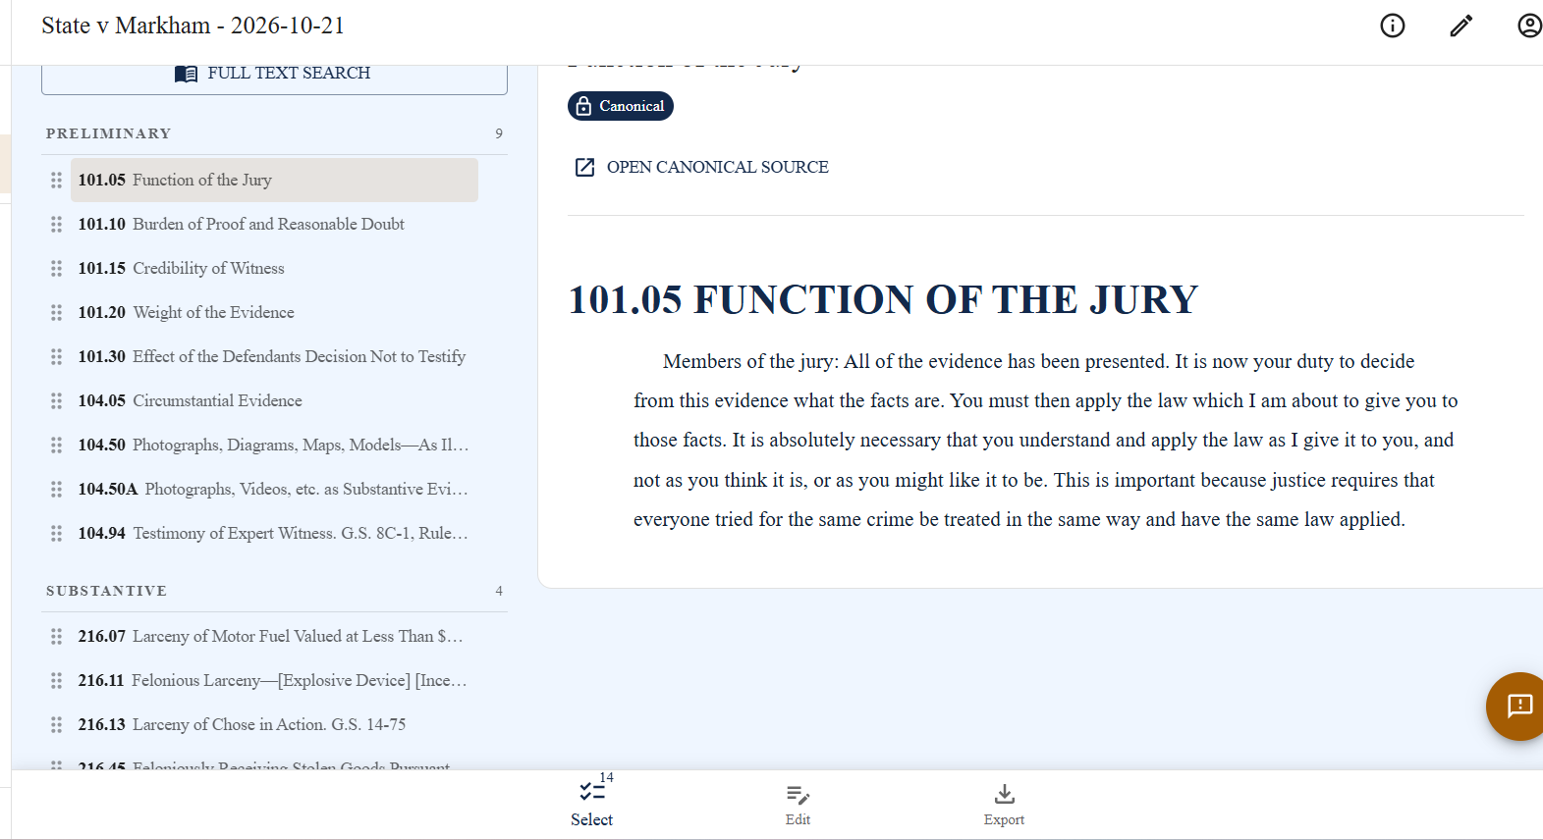
- To rearrange the order of the instructions, place your cursor on the 6 dots to the left of the instruction, hold and move up or down as needed to put in a different order

- As you add instructions, or before you are ready to export your instructions, you can edit individual instructions in the app by clicking on the Edit button at the bottom of the screen.
  - You can then add, remove or format text in the instruction. This will keep the changes in the version of the instructions you save within the app.
  - You can also edit the whole set of instructions for the case after you export to Word.
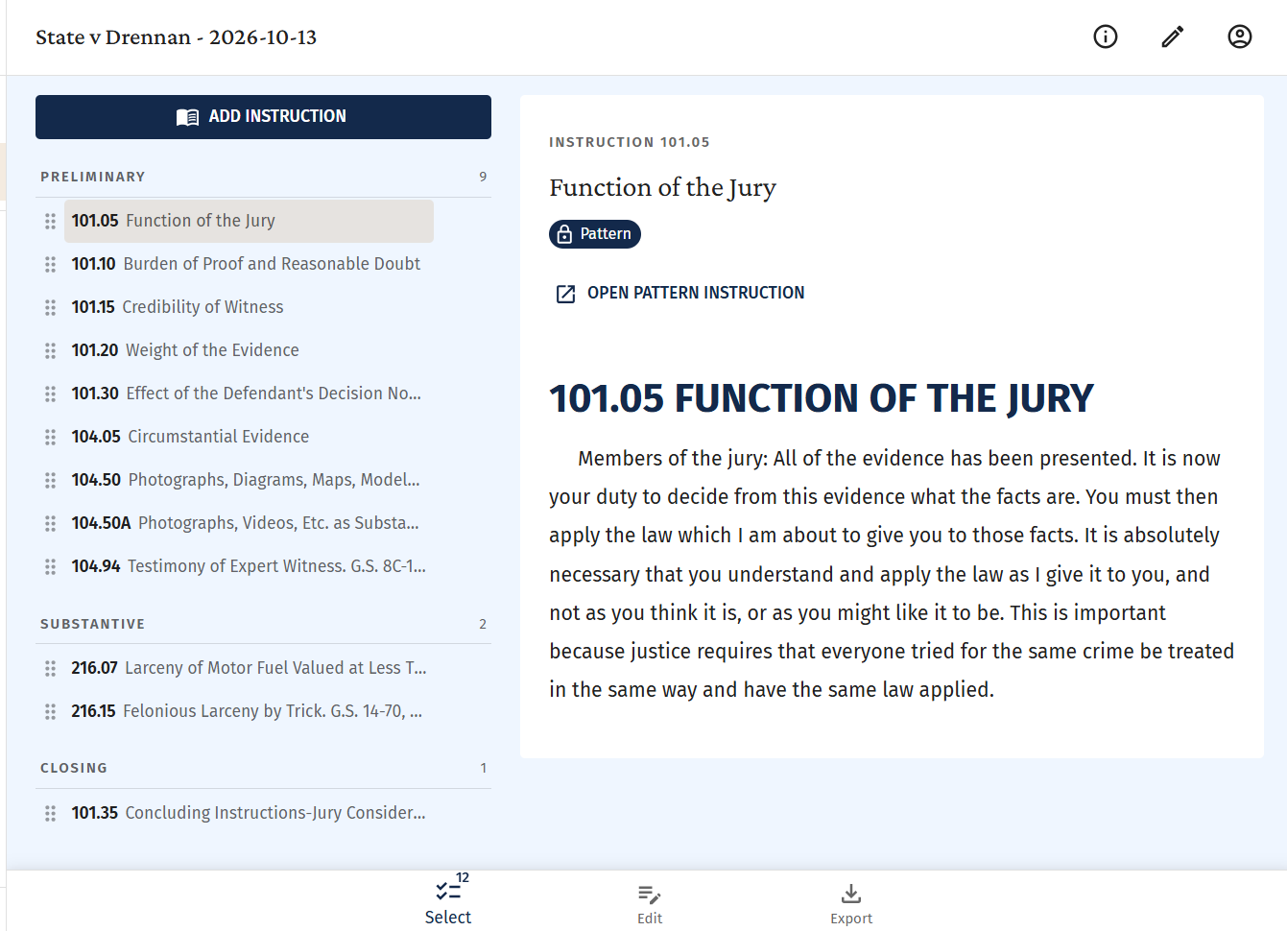
- To export the full set of instructions to be edited or distributed, click the Export button at the bottom of the page.
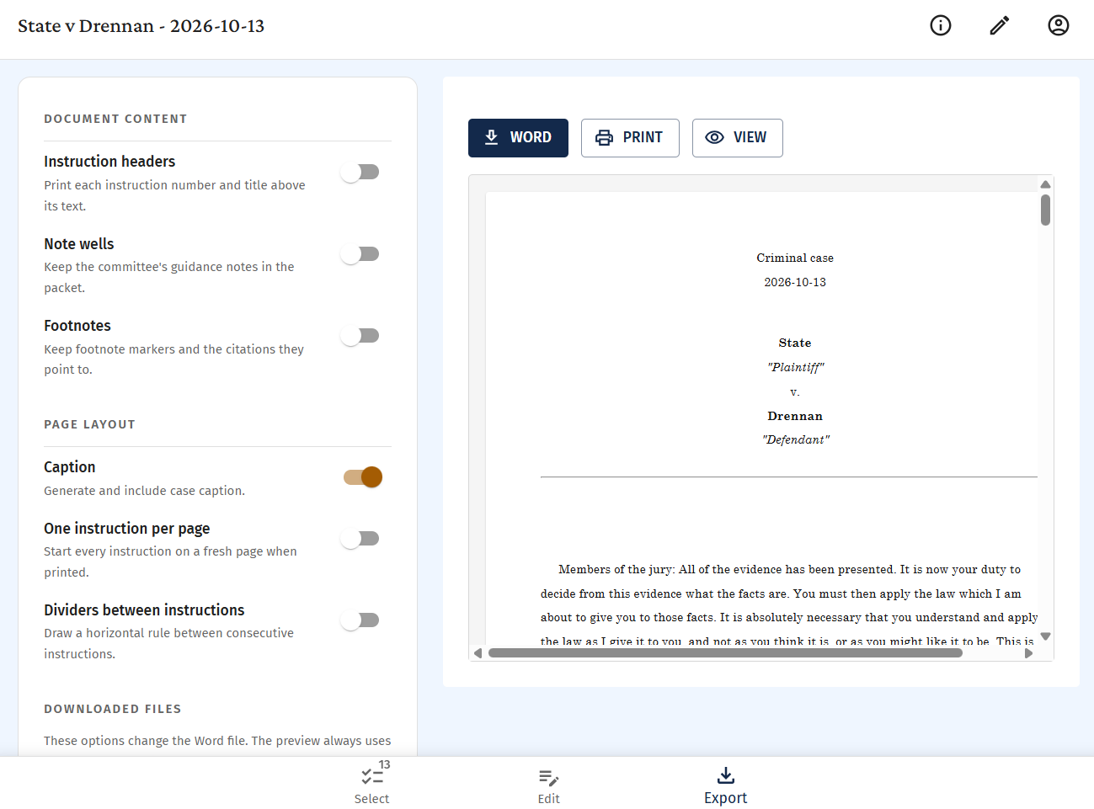
- In the final window, you can select from many output options.
  - You can choose to include instruction headers, note wells or footnotes.
  - You can also choose to include a cover page or limit the instructions to one instruction per page.
  - As you make these changes, they will update in the preview of the instructions on the right side of the screen.
  - You can choose to download the case instructions in Word or as a PDF. You can also choose to view/preview it on your screen.

