MEMORANDUM

TO: North Carolina Superior Court Judges and District Court Judges

FROM: The North Carolina State Bar Office of Counsel

RE: Liaison to the Judiciary

In order to enhance communication, improve collaboration, and provide better assistance to North Carolina judges, the State Bar’s Office of Counsel has designated Deputy Counsel Carmen Bannon as the office’s Judicial Liaison.

The judicial liaison will serve as the primary point of contact for judges who contact the State Bar, and as a resource for information about various options available to judges to address the conduct of lawyers who appear before them. The liaison will also track concerns reported by judges, even in instances where the judge does not wish to initiate a formal grievance at the time of the report. This will enable the State Bar to aggregate individual reports and identify patterns of problematic conduct. The liaison will also be available to you to answer questions about the Rules of Professional Conduct, and to discuss the benefits and drawbacks of addressing a particular situation either in the court or through the State Bar’s grievance process.

Issues you may want to report to—or discuss with—the liaison include:
- A lawyer has recently been removed from the appointed list due to concerns about performance
- Is incivility (between counsel or directed at the court) merely a professionalism issue, or is it something the court or the Bar should get involved in?
- A lawyer is chronically late and/or absent from court
- A lawyer gave false testimony or made a false statement to the court
- A lawyer filed a wholly frivolous lawsuit or motion
- A lawyer has alleged misconduct by another lawyer

To ensure that judicial inquiries receive a prompt response, and to provide for consultation and/or reporting outside of regular business hours, judges may contact Carmen any time, either at her direct office number, 919-719-9283, or on her cell phone, 919-302-8034. If a judge calls the main State Bar number and does not request to speak to a specific member of the staff, the call will be routed to Carmen.

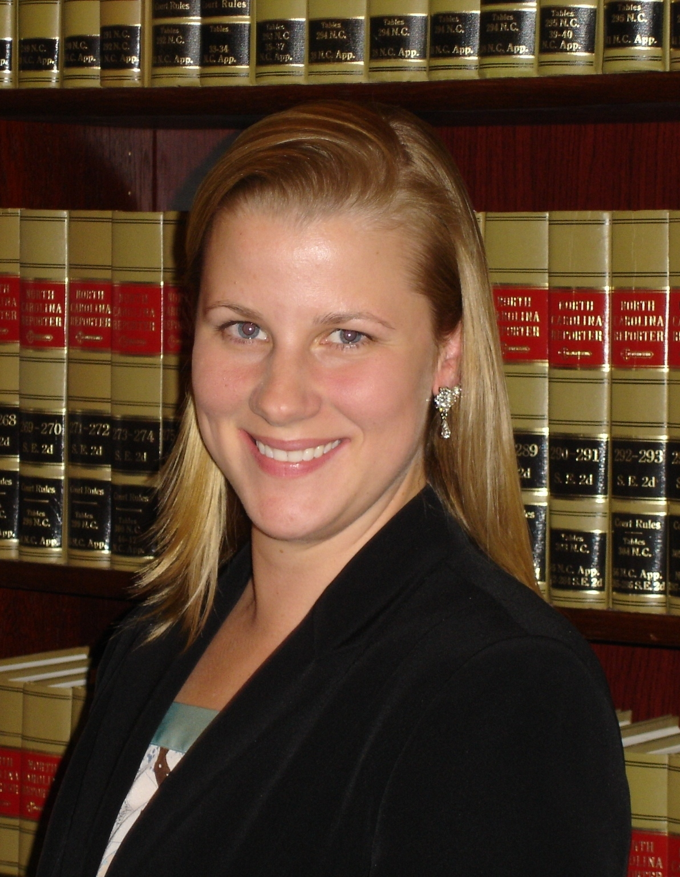
JUDICIAL LIAISON CONTACT INFORMATION:
Carmen H. Bannon, Deputy Counsel
North Carolina State Bar
P.O. Box 25908
Raleigh, NC 27611
cbannon@ncbar.gov
919-719-9283 (direct)
919-302-8034 (cell)
919-834-8156 (fax)

