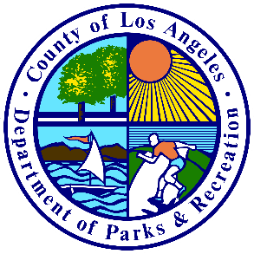
Los Angeles County Department of Parks and Recreation &
Los Angeles County Department of Public Health Office of Violence Prevention
Trauma Prevention Initiative



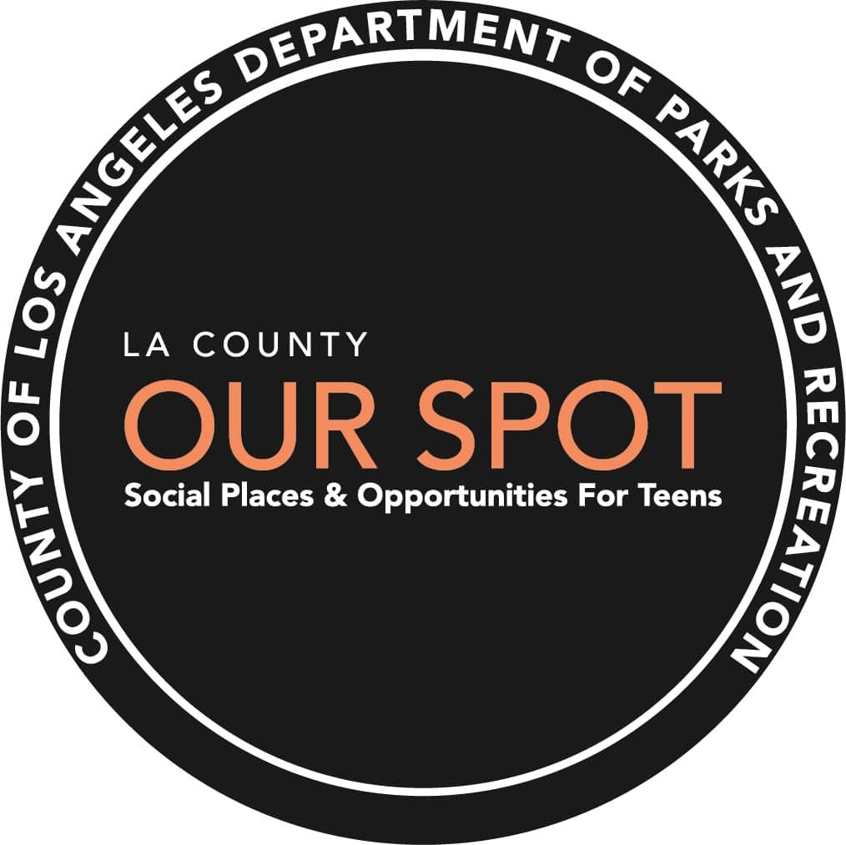

OUR SPOT Program Evaluation Report

June 2021
FUNDED BY THE LOS ANGELES COUNTY DEPARTMENT OF PROBATION



1

TABLE OF CONTENTS
Contents
Introduction .................................................................................................................................................. 3
About Our SPOT ........................................................................................................................................ 3
Our SPOT Locations................................................................................................................................... 3
Purpose of Study ....................................................................................................................................... 4
Program Model –A Literature Review of Positive Youth Development ....................................................... 4
Positive Youth Development (PYD)........................................................................................................... 5
Trauma Informed Approach ..................................................................................................................... 5
Holistic Health and Wellness .................................................................................................................... 6
The Arts and Self-Exploration ................................................................................................................... 9
Evidence-Based and Evidence-Informed Curricula ................................................................................. 10
Principles of Successful Youth Program Implementation and Staffing .................................................. 12
Evaluation Overview ................................................................................................................................... 14
Methods .................................................................................................................................................. 14
Findings: Program Implementation ............................................................................................................ 18
Our SPOT Park Profiles in Underserved Communities............................................................................ 18
Program Dosage...................................................................................................................................... 21
Participant Demographics....................................................................................................................... 23
Enrollment & Participation ..................................................................................................................... 23
Program Access....................................................................................................................................... 24
Program Quality ...................................................................................................................................... 27
Findings Across Perspectives: Themes & Takeaways ................................................................................. 34
Perspectives on Youth Population .......................................................................................................... 34
Emerging Youth Perceptions................................................................................................................... 35
Emerging Staff Perceptions..................................................................................................................... 36
Stakeholder recommendations for program improvement: .................................................................. 38
Summary & Implications for the Future ..................................................................................................... 39

2

Introduction

About Our SPOT

Funded by the Los Angeles County Department of Public Health (Substance Abuse and Prevention Control Program (SAPC) and the Los Angeles County Department of Probation, Our SPOT (Social Places and Opportunities for Teens) provides positive youth development through recreational programs in a safe space at select county parks to teens in grades 7-12. The program, implemented by the Los Angeles County Department of Parks and Recreation (DPR) is provided for free and operates Monday through Friday from 3-7 pm.
Recently, DPR adopted a health equity and social justice framework as central to its mission, particularly in the unincorporated areas of the County where equitable allocation of resources and prevention recreation programs can help mitigate some of the systemically rooted effects of community violence, socio-economic inequalities, and racism facing underserved communities. Our SPOT operates in the unincorporated areas of the County, many of which are in communities with concentrated poverty. Our SPOT locations are selected based on the size of youth population, drop-out rate, proportion of households below the federal poverty level, crime index score and parks’ needs assessment. This method of park identification has led to the opening of Our SPOT at 13 of 183 (or 7.1%) of DPR park locations.
The Our SPOT program design is grounded in the research literature on positive youth development with a strong emphasis on trauma informed care and integration of health and fitness, social-emotional learning, mindfulness and self-care. Our SPOT utilizes engaging programming in arts and self-exploration, youth leadership, life skills and healthy development, career pathway exploration, educational field trips, mental health and resilience education including substance abuse prevention, and special events promoting self-empowerment.

Our SPOT Locations

At the beginning of the 2020-21 fiscal year, the Our SPOT program operated in 10 community parks across Los Angeles County which included Amelia Mayberry Park, City Terrace Park, El Cariso Community Regional Park, East Rancho Dominguez Park (ERD), Franklin D. Roosevelt Park (FDR), Loma Alta Park, Mona Park, Salazar Park, San Angelo Park, and Stephen Sorrensen Park. During the year, the program expanded to three additional parks: Belvedere Park, Lennox Park, and Pamela Park.
The original 10 parks were operationally organized around three geographic regions: North, South and East. The target youth population ranged in age between 12-18 years of age drawn from the local communities within a few miles of each park.

3

Purpose of Study

The purpose of this report is to document and describe how the Our SPOT program has been implemented, now in its second year (fiscal year 2020-21), and any measurable impact it has had on participating youth. To achieve this goal, the following research questions, continued from the first year of implementation, remain of interest:
- How was the program implemented?
- What were the experiences of participants?
- What were the successes and challenges of the program?
- How did the program impact participating youth?
The report is organized into the following sections: Introduction, Program Model, Findings and Recommendations. Additional information is also provided in the appendices.

Program Model –
A Literature Review of Positive Youth Development

The Los Angeles County Park and Recreation Department’s “Our Social Places and Opportunities for Teens “ (Our SPOT), is based on the general principles of Positive Youth Development. Using this framework as a foundation, Our SPOT builds upon the strengths-based tenets of positive youth development, and incorporates a myriad of evidence-based and evidence-informed programs and interventions, each of which was selected because of the cultural relevance for teens navigating complex urban environments.
The following literature review provides an overview of the tenets supporting the Our SPOT model. First, this review identifies the theoretical underpinnings of the positive youth development framework and provides a summary of the empirical support for similar programs that utilize this framework in their program development and implementation. Second, the review highlights the strength of evidence related to the major programmatic components of Our SPOT, including holistic health and wellness (i.e., socio-emotional learning, Cognitive- Behavioral Models, and Mindfulness and Self Care), leadership development, recreation and sports, integration of the arts for self-exploration, as well as career pathways and educational goal-setting. Third, the review explores the reported impact and effectiveness demonstrated in specific curricula and other evidence-based interventions that are embedded in the Our SPOT program including Youth Engaged in Leadership (Department of Public Health); Mental Health Promoters (Department of Mental Health); Resilience and Intergroup Solidarity Education (R.I.S.E.) (Human Relations Commission); Say Goodbye to Drugs; and Youth Power. In addition, this review lends empirical support for the implementation strategies employed including

4

