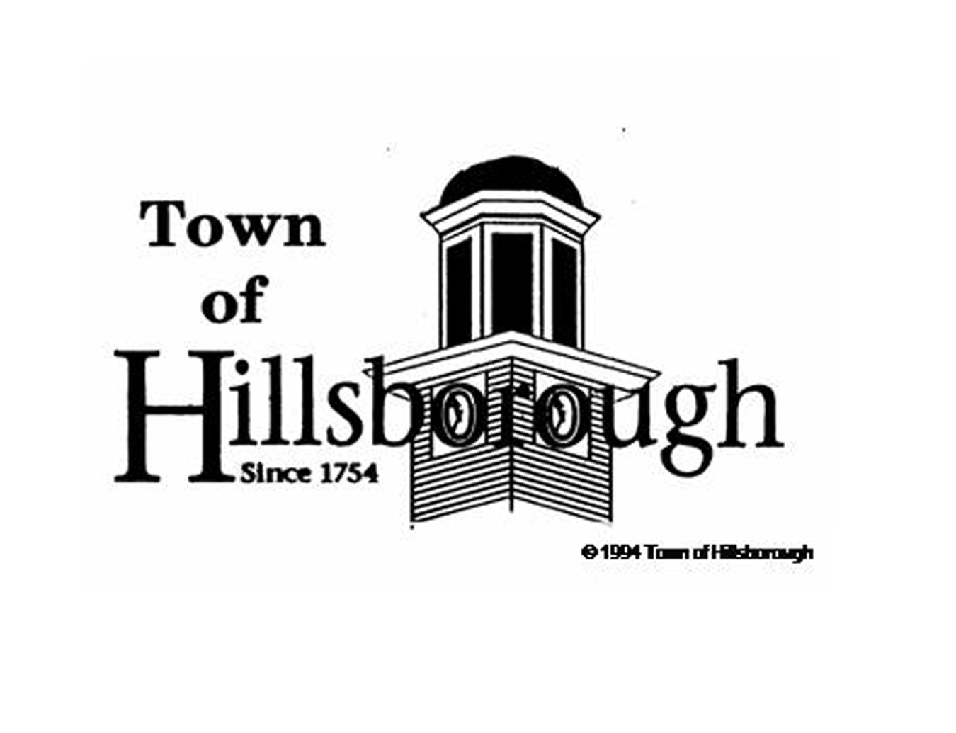

FY2011-12

Citizen Survey

Dear Hillsborough Citizen:

We are conducting our bi-annual Citizen Survey in which we randomly select and survey 25 percent of the Town’s households for their opinions about the Town’s programs and services. The Town will use the results of this survey to benchmark how it is doing in the development, monitoring and evaluation of priorities. These priorities will be tracked through the annual budget and operational planning process. Please take a few minutes to answer the questions below. At your earliest convenience, please submit your responses via the self-addressed and stamped envelope provided. Your feedback is invaluable and we appreciate your participation in this anonymous survey. *Deadline to submit survey is Friday, September 21, 2012.*

Sincerely,

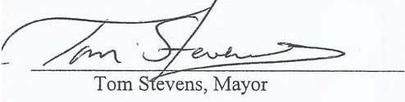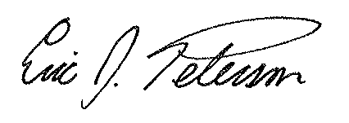

Tom Stevens, Mayor Eric Peterson, Town Manager

**On a scale of 1 to 10, with 1 = strongly disagree, 6 = agree, and 10 = strongly agree, how do you feel about the following statements?** (Circle the number)

Strongly Strongly

Disagree Agree

1 2 3 4 5 6 7 8 9 10

1 2 3 4 5 6 7 8 9 10

1 2 3 4 5 6 7 8 9 10

1 2 3 4 5 6 7 8 9 10

❒Yes ❒ No

1 2 3 4 5 6 7 8 9 10

**Public Safety**:

Hillsborough is a safe place to live and work………………..…………………………....……….……………………..……..................

I feel safe in my neighborhood………………….……………………………..……………………………………………………

Hillsborough police have a visible presence around Hillsborough……....……...…..……………………………………......

Hillsborough police have a visible presence in my neighborhood / workplace……...……….…..…………………………..…….……....

I have had opportunities to interact or speak with Hillsborough police officers (outside of enforcement actions) ………………………

If yes, please rate the following statement:

Hillsborough police officers left a favorable impression on me when I spoke or interacted with them……………………………………….......

Strongly Strongly

Disagree Agree

1 2 3 4 5 6 7 8 9 10

1 2 3 4 5 6 7 8 9 10

1 2 3 4 5 6 7 8 9 10

1 2 3 4 5 6 7 8 9 10

1 2 3 4 5 6 7 8 9 10

1 2 3 4 5 6 7 8 9 10

1 2 3 4 5 6 7 8 9 10

1 2 3 4 5 6 7 8 9 10

**Services / Governing / Town Management:**

The Town is responsive to the needs of citizens……..……………..………..……………………………………………….…….

I have access to Town officials and staff when I have a concern……………...….…………………………………….….......

Town employees treat customers courteously………………………………………………………………………………..……...

Town employees do their jobs in a professional manner………………………………………………………….....................

Customer Service staff (located at Town Hall Annex) are helpful…………………………………………………………………….

I feel that the Town spends my tax dollars wisely………….…………………….……............................................................

I feel that the water and wastewater services received are of good quality………….…………………….……................................. .

I feel that the water and wastewater services received are a good value.…………………….……...................................................................................................................

Strongly Strongly

Disagree Agree

1 2 3 4 5 6 7 8 9 10

1 2 3 4 5 6 7 8 9 10

1 2 3 4 5 6 7 8 9 10

**Communication:**

I feel informed about the Town and its services……………………………….…………………………………….…………… …

I regularly visit the Town’s website to get information about Town services and key issues…………………………………………………..

The Town’s website is easy to navigate………………………………………….….…………………………….…………….

Have you ever visited the Town’s website? (check one)  Yes  No

If yes, do you visit the Town’s website: (check one)  Daily  Weekly  Monthly  Less than once a month

Have you ever watched the Town’s Government Access Channel (Channel 18 on Time Warner Cable)? (check one)  Yes  No

If yes, do you watch the Town’s Government Access Channel: (check one)  Daily  Weekly  Monthly  Less than once a month

The best way to communicate with you: (check one)

Newspaper  Email  Town Website  Town Newsletter  Water/Sewer Bill  Direct Mailing  Government Access Channel (Ch.18)

Is there a better way to contact you?

If you wish to have your email address added to the Town’s listserv, please provide it here:

Do you feel more informed about the Town and its services than you did a year ago? (check one)  Yes  No

**(Over for Comments/Suggestions)**

**Comments/Suggestions:**

What are the biggest issues facing Hillsborough?

What can the Town do to improve its services?

Is there information you would like to see on the Town’s website or government access channel that is not currently provided?

**Thank you!**