How can I add content / edit content on my microsite?
Adding content to microsites is a frequent task for faculty and staff. Typically, your microsite will consist of:
- The microsite landing page – this page contains your site banner, your welcome message, the list of site ‘contributors’ and the categories (roles and topics).
- Several Basic Pages with various content.
- Resource Series – these are collections of courses, publications, course material, … This content type is used to create an archive with dynamic references – if any item is updated, the list automatically updates as well. You can choose what the title of this list should display: Publications, Courses or Resources.
- Legal Summary collection – this content type works exactly like a resource series, but is solely used to list legislative summaries, case summaries, bill summaries and other legal information.
- FAQ Collection: If your microsite contains a list of frequently asked questions, it is likely curated in an FAQ collection, which allows users to fold and expand the list of questions and answers.

You can edit the microsite landing page to change the overview text, the banner image, the list of contributors, or the roles and topics that determine where in the menu your microsite will be listed.
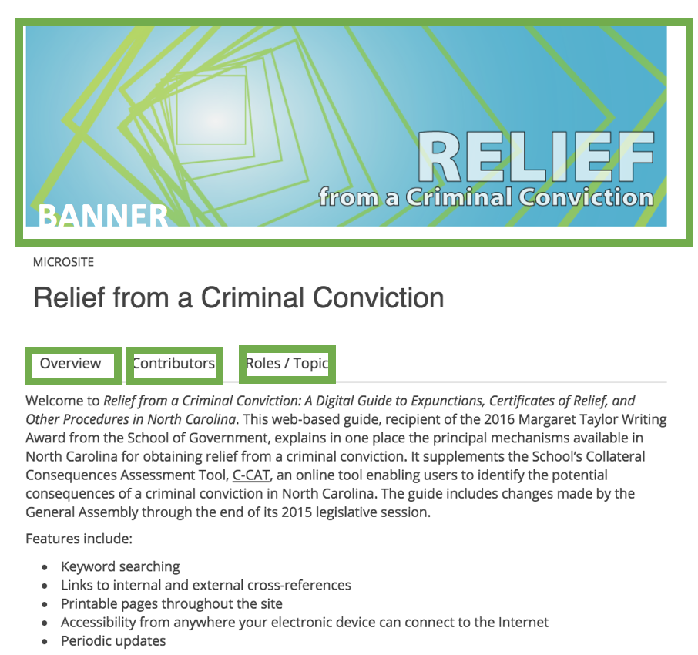

You can easily edit any ‘Basic Page’ in the WYSIWIG editor.

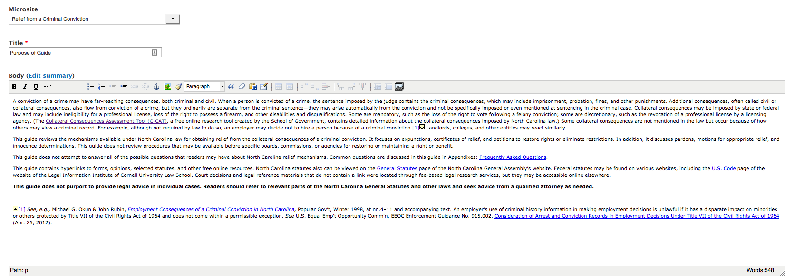

All other document types for microsites (resource series, legal summary collection and FAQ collection) work similarly. They have two components: The introduction, which you can edit in the HTML editor, and the individual items which are added as a document reference. This document explains the principle with the example FAQ.

An FAQ collection has two components: The introduction, which you can edit in the HTML editor, and the individual FAQs which are added as a document reference.

To edit an individual FAQ, expand it and click the link ‘Edit’ below the main text:

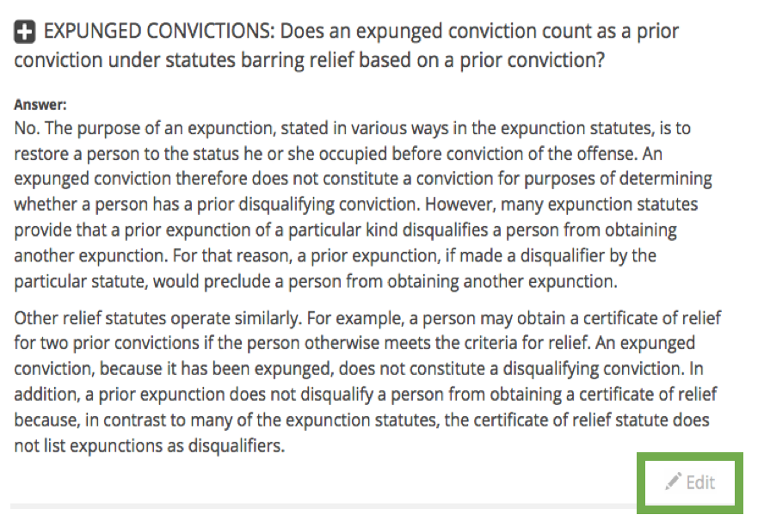

To add a new FAQ, you will need to access the content editor.

First click on the person icon in the main menu, second click on editor tools.
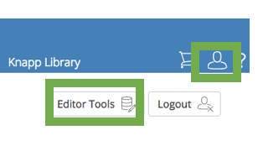
Third, select ‘Add content’ in Editor Basics.
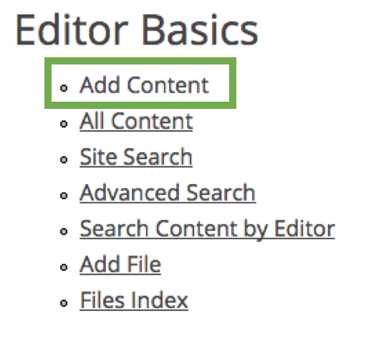
Choose the content type FAQ. Create and save the FAQ. Now you can add it to the exisiting FAQ collection on your microsite.

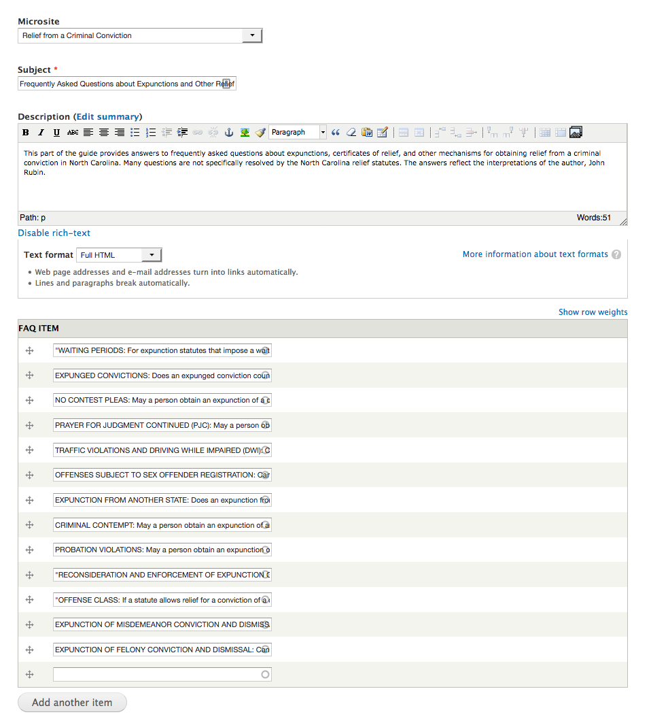
Start typing the title of the FAQ item, and it will autocomplete.
Click ‘Add another item’ and save.

