How can I create a webform to collect data through the School of Government website?

Webforms are a great way to collect information, send out email notifications to clients and School employees whenever a form is submitted, and download the results in an Excel sheet. Webforms are frequently used for course that require pre-registration applications. The webforms are connected to the course offering.

To create or edit webforms, and to access the submission results of an existing webform, you need to log in to the website and access the editor tools.

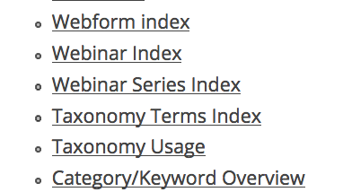

Your first step is to figure out if you need to set up a new form, or if the form you want to use already exists. Typically, course application webforms are already in place. Access the webform index to check. https://www.sog.unc.edu/editor-tools/webform-index

You can search the index by title or user – simply type in your email address to see al forms created by you.
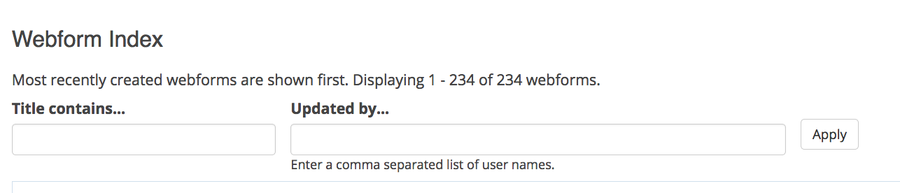

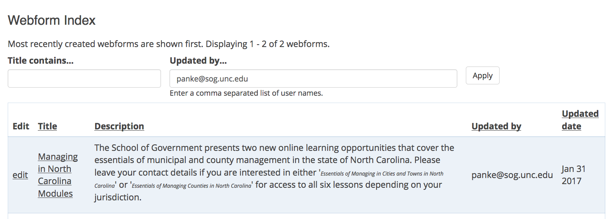

You can access the results of any webform by clicking on the form’s link, and accessing the ‘results’ button.

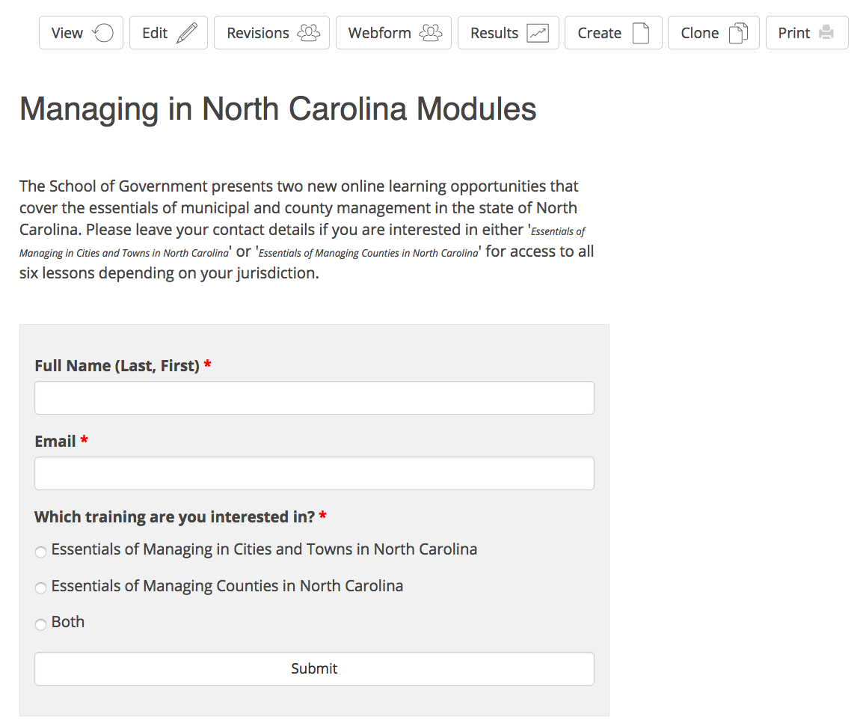
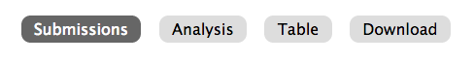
You can view the submissions in a results table, access each submission individually, or download the data as a whole in an excel sheet.

To create a new webform, go to the editor tools, create content, and select the webform option: https://www.sog.unc.edu/node/add/webform

First, set up a title and description (optional). The description will be the introductory paragraph of your form. Click ‘save.’

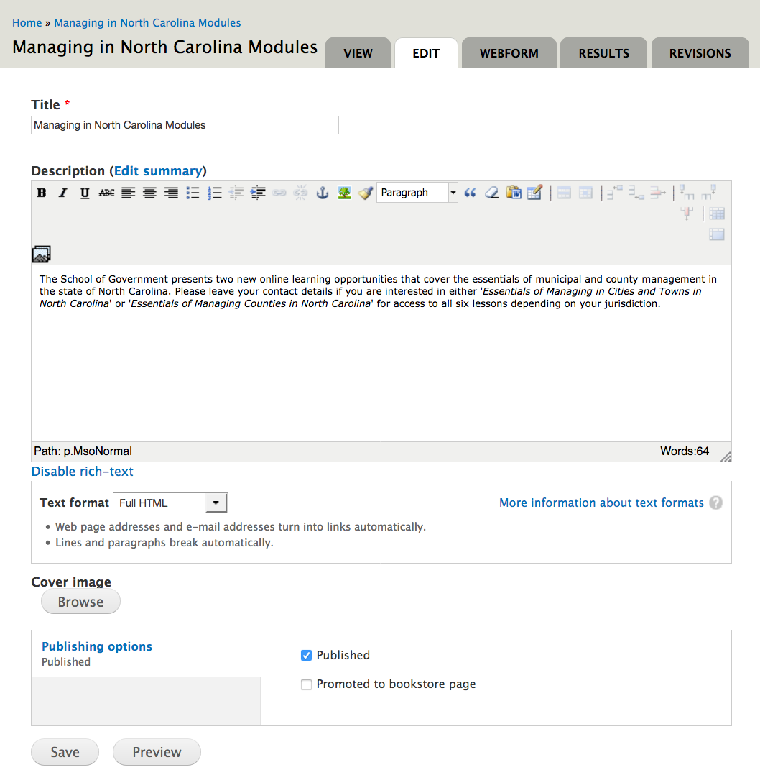
To add or edit the actual questions and form components, you will need to select the tab ‘webform’.

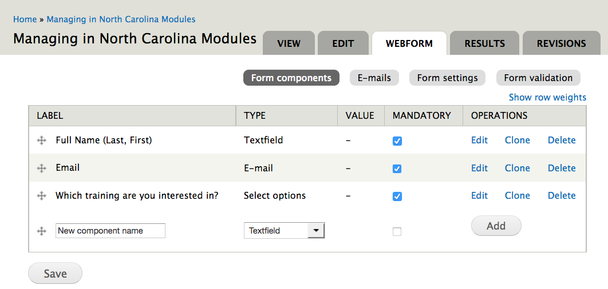

You need to create each form component by selecting an option from a drop-down list.
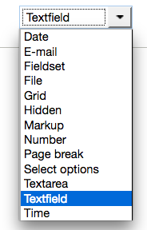

Most relevant are:
- Textfield: one line text input, e.g., first, last name
- E-Mail: email address for confirmation messages or follow-up
- Select options: Single or Multiple choice
- Textarea: multiple line text field
- File: file upload
In the emails section, you can set up who should be notified by email when a form is submitted.
Under ‘component value’ you have the option to send an email to the person who submitted the form.
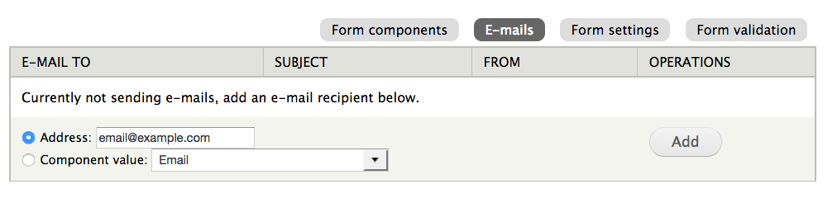

Under ‘Form settings’ you can craft a follow-up page that displays once users hit the submit button, or enter a redirect to a new page.

