How can I create an FAQ List?
Creating an FAQ list that allows users to expand and collapse questions to quickly navigate to the information they need is easy on the website. You will need two different content types: FAQ for the individual question and answer pairs and FAQ collection for the overview.

Example FAQ:
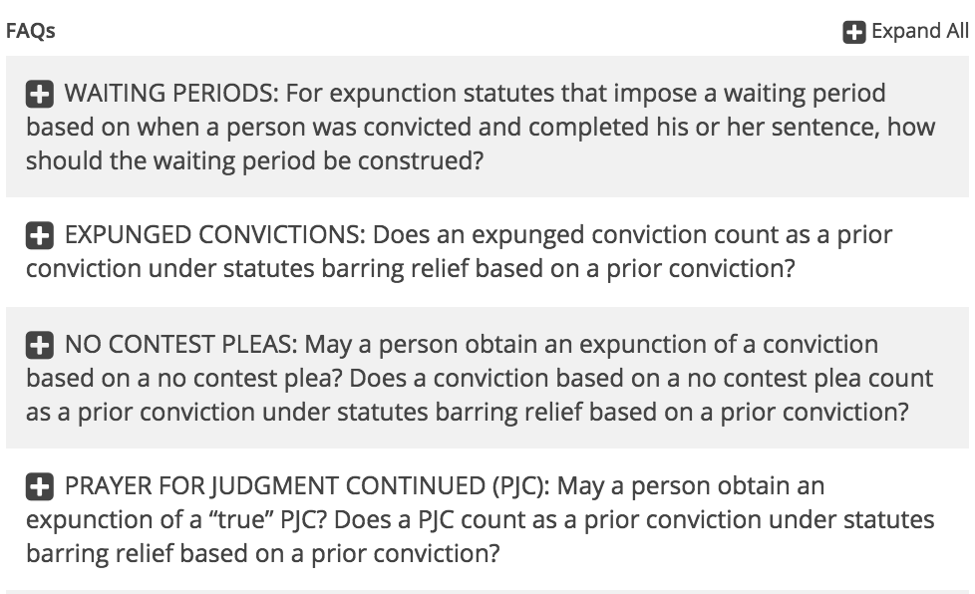

To add a new FAQ, you will need to access the content editor.
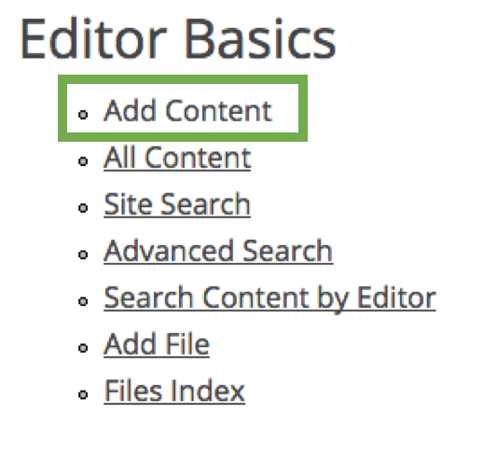
Choose the content type FAQ.

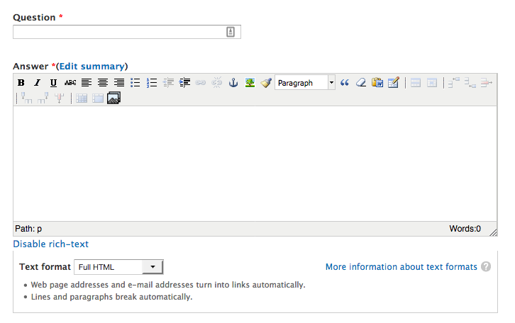

The only two fields you will likely need are question and answer.
You mat now save the FAQ, or add additional information.

In some cases, you may want to add a file, a website to your FAQ.

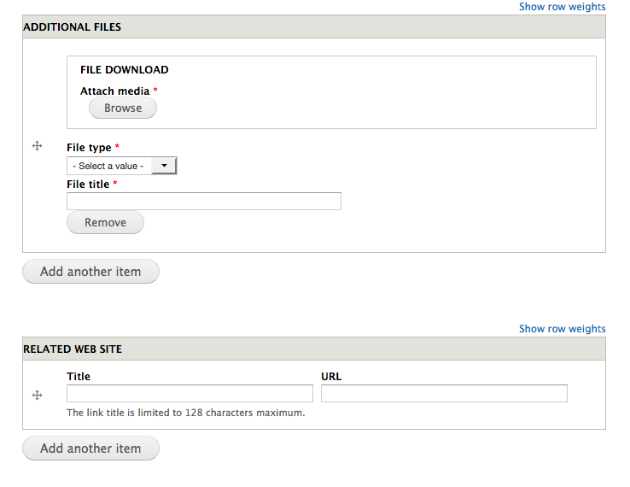

Following this approach, create as many FAQ items as you need. You can add more anytime.

Next, choose the content type ‘FAQ collection’.
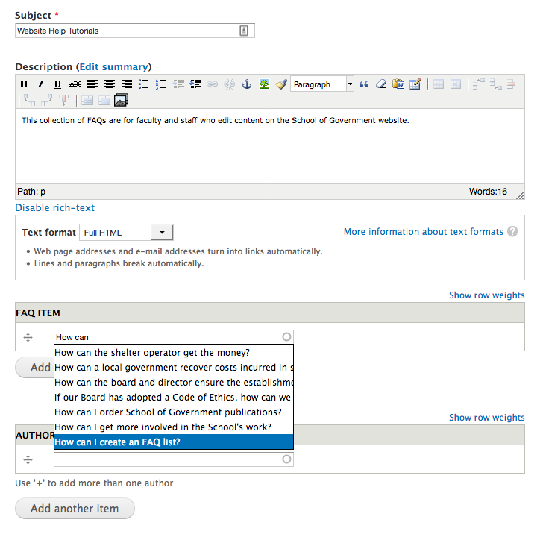

Here you can add the existing FAQ to your new FAQ collection: Start typing the title of the FAQ item, and it will autocomplete.

Click ‘Add another item’ and save to create your FAQ list or add additional information.

You can add one or several authors to the page:
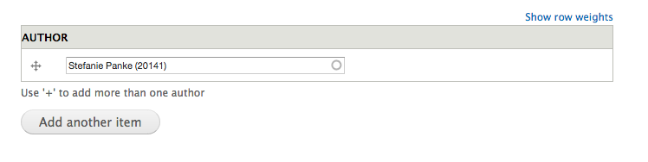
You can associate related content that will display in the sidebar under ‘SEE ALSO’.
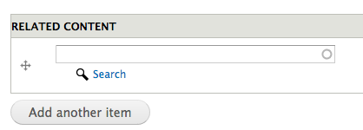

Use the taxonomy at the bottom of the page to control where in the menu your FAQ collection will display.

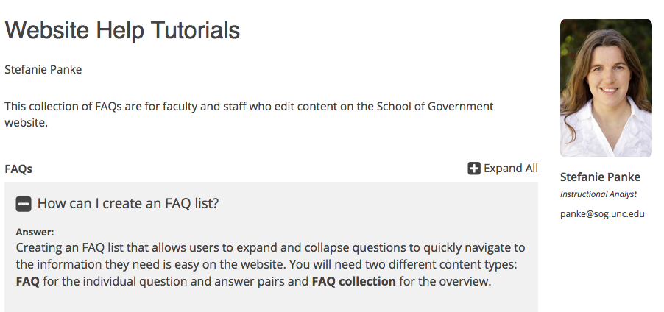

To edit an individual FAQ, expand it and click the link ‘Edit’ below the main text:

