How can I manage and update pages?
If you frequently contribute content to the School of Government website, it becomes an ongoing task to update content and keep track of what is out there, which includes replacing outdated documents. We help you keep track of courses, resources, microsites and publications through several indexes.

To obtain an overview of your web resources, you need to access the editor tools.
First click on the person icon in the main menu, second click on editor tools.
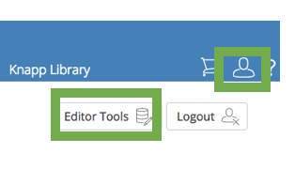
Third, select the option you need from Editor Indexes, Lists & Usage or Search Content by Editor: https://www.sog.unc.edu/editor-tools/search-by-editor
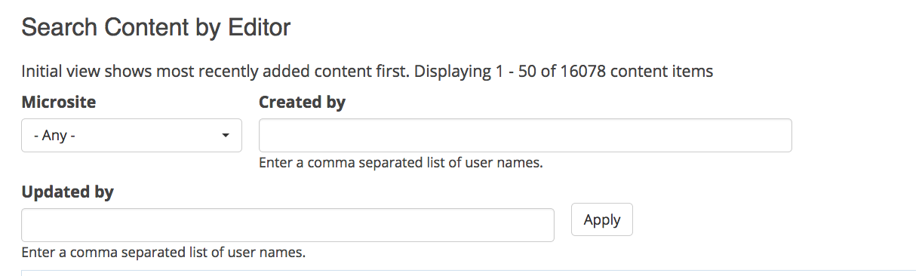

Indexes that haven proven to be particularly useful to content editors are:

Courses and Webinars:
Courses and Webinars by Program Manager: https://www.sog.unc.edu/editor-tools/program-manager-central
Course Offering Index: https://www.sog.unc.edu/editor-tools/course-offering-index
Course Material Index: https://www.sog.unc.edu/editor-tools/course-material-index

Webforms:
Webform Index: https://www.sog.unc.edu/editor-tools/webform-index

