How can I add a document to my microsite?
Adding a PDF or Word document to a microsite is frequent task for faculty and staff. What is the easiest and most effective way to do this? The answer depends on how easy you want you content to be found, archived, and reused. If the document is intended only for this page and you do not think you need to update it in the future, you can quickly add any file in the WYSWIG editor. If you want a stable web address for your document, the ability to update it over time, and add it to the School’s document pool so that it is indexed in the site-wide search, choose ‘Legal Summary’.

Adding a document quickly and easily with the WYSIWIG:
Move your cursor to the position where you want to place your document link.
Click the ‘file upload’ symbol:
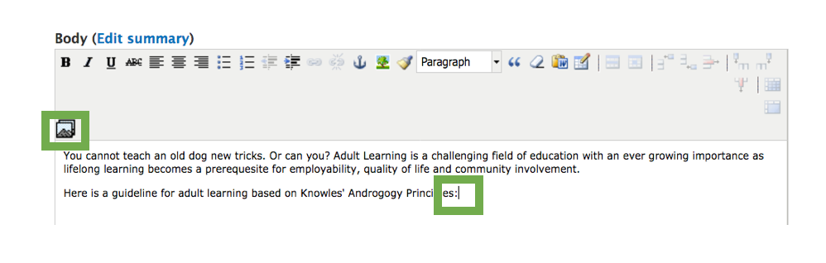
Now, follow the steps to either select an existing document from the library or your personal uploads, or choose a document on your computer to upload.

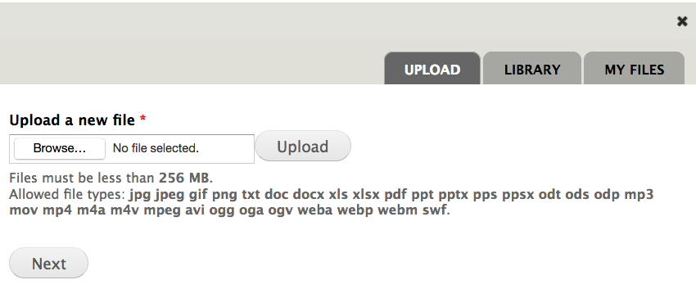
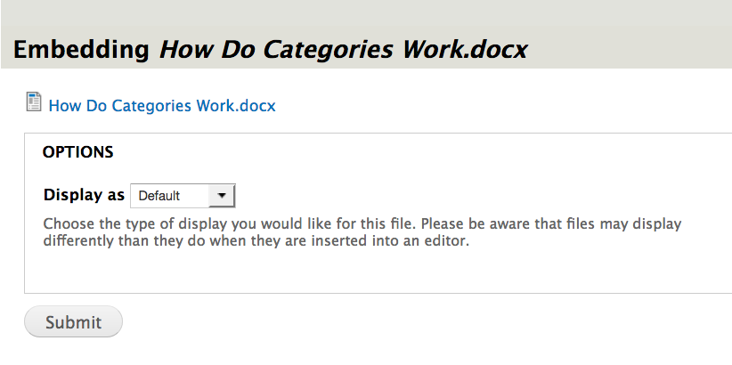
Leave the display option as ‘default’ and enter submit.
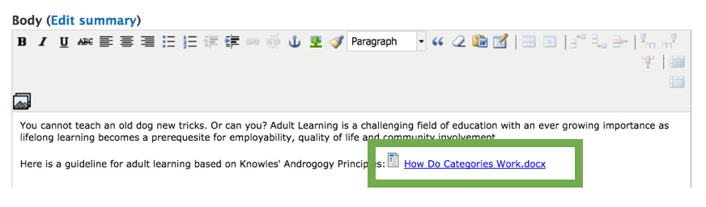
Your document is now hyperlinked on your page. Conform the changes by saving.

Adding a document as ‘Legal Summary’.
Click the create button on top of your page.

Create a new legal summary.

Choose the type that best describes your document:

Use ‘additional files’ to upload your document:

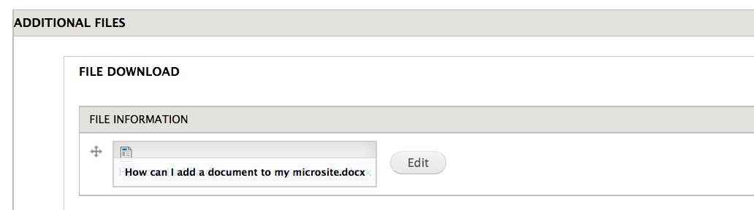

(You can add more than one document if you wish).

Add categories for easier retrieval – this will make your document show in the topics and public officials menus.

Save the page.
.

Copy the URL of the legal summary page and add it as a hyperlink to your microsite.

